DEPARTMENT OF LICENSING AND REGULATORY AFFAIRS

DIRECTOR'S OFFICE

CONSTRUCTION CODE

Filed with the secretary of state on

These rules become effective 120 days after filing with the secretary of state.

(By authority conferred on the director of the department of licensing and regulatory affairs by section 4 of the Stille-DeRossett-Hale single state construction code act, 1972 PA 230, MCL 125.1504, and Executive Reorganization Order Nos. 2003-1, 2008-4, and 2011-4, MCL 445.2011, MCL 445.2025, and MCL 445.2030)

R 408.31087, R 408.31088a, 408.31093 and R 408.31098c of the Michigan Administrative Code are amended, R 408.31091a is added, and R 408.31087a, R 408.31087b, R 408.31088, R 408.31090, R 408.31091, R 408.31092a, R 408.31094, R 408.31095, R 408.31096, R 408.31097, R 408.31098, R 408.31098a, and R 408.31098b of the Michigan Administrative Code are rescinded, as follows:

PART 10a. MICHIGAN ENERGY CODE

R 408.31087 Applicable code.
Rule 1087. Rules governing the energy efficiency for the design and construction of buildings and structures, not including residential buildings, shall be those contained in the international energy conservation code, 2015 2021 edition, including appendix CB, except for sections C104.2 to C104.5, C107.2 to C107.5, C108.2 to C108.4, C109.1 to C109.4, C110.1 to C110.3, C301.2, C301.3, C302, C401.2.1 to C408.3.2, C502.2 to C502.2.6.2, C503.2 to C503.6 appendix CA, and appendix CC and the ASHRAE energy standard for buildings, except low-rise residential buildings, ANSI/ASHRAE/IESNA standard 90.1-2013 2019 (hereafter, referred to as the standard in these rules), including appendices A, B, C, D, E, F and G, H, and I. except for sections 8.4.2,8.4.3 to 8.4.3.2. With the amendments noted, the international energy conservation code and the standard are adopted by reference in these rules by reference. The Michigan energy code is available for inspection at the Lansing office of the Michigan Department of Licensing and Regulatory Affairs, Bureau of Construction Codes, 611 W. Ottawa Street, Lansing, Michigan 48933. The code may be purchased from the International Code Council, through the bureau’s website at www.michigan.gov/bcc, at a cost as of the time of adoption of these rules of $44.00 $52.00. The ASHRAE 90.1- 2013 2019 standard is available for inspection at the Lansing office of the Michigan Department of Licensing and Regulatory Affairs, Bureau of Construction Codes, 611 West Ottawa Street, Lansing, Michigan 48933. The standard may be purchased from the American Society of Heating, Refrigeration and Air-Conditioning Engineers, Inc., 1791 Tullie Circle, NE, Atlanta, Georgia 30329, 180 Technology Parkway North West, Peachtree Corners, Georgia 30092, or from https://www.ashrae.org at a cost as of the time of adoption of these rules of $135.00 $177.00 each.

R 408.31087a Scope. Rescinded.
Rule 1087a. Section C501.1 of the code is amended to read as follows:
C501.1. Scope. The requirements contained in this chapter are applicable to commercial buildings, or portions of commercial buildings. These commercial buildings shall meet the requirements of ASHRAE/IESNA Standard 90.1, “Energy Standard for Buildings Except for Low-Rise Residential Buildings, and the requirements contained in this chapter.

R 408.31087b Application. Rescinded.
Rule 1087b. Section C401.2 of the code is amended to read as follows:
C401.2. Application. Commercial buildings shall comply with the requirements of ANSI/ASHRAE/IESNA 90.1-2013.

R 408.31088 Definitions. Rescinded.
Rule 1088. The definitions of building and building official in section 202 of the code are is amended to read as follows:
202. Definitions.
“Building” as defined in the Stille-DeRossett-Hale single state construction code act, 1972 PA 230, MCL 125.1501 to 125.1531.
"Building official" as defined in the Stille-DeRossett- Hale single state construction code act, 1972 PA 230, MCL 125.1501 to 125.1531.

R 408.31088a Scope; requirements.
Rule 1088a. Sections C101.1 is amended to read as follows:
C101.1. Title. This code shall be known and cited as the “Michigan Commercial Energy Code.” It is referred to herein as “this code.” in these rules.

R 408.31090 Administrative requirements. Rescinded.
Rule 1090. Section C104.8 of the code is added to read as follows:
C104.8. Administrative requirements relating to permits, enforcement, interpretations, and appeals shall be pursuant to the Stille-DeRossett-Hale single state construction code act, 1972 PA 230, MCL 125.1501 to 125.1531.

R 408.31091 Existing buildings. Rescinded.
Rule 1091. Sections C502.1, C503.1, C504.1, and C505.1 of the code are amended to read as follows:
C502.1. Additions. Additions shall comply with ASHRAE 90.1-2013, section 4.2.1.2.
C503.1. Alterations. Alterations to any building or structure shall comply with the requirements of ASHRAE 90.1-2013, section 4.2.1.3.
C504.1. General. Buildings and structures, and parts thereof, shall be repaired in compliance with section C501.3 and this section. Work on nondamaged components that is necessary for the required repair of damaged components shall be considered part of the repair and shall not be subject to the requirements for alterations in this chapter. Routine maintenance required by section C501.3, ordinary repairs exempt from permit and abatement of wear due to normal service conditions shall not be subject to the requirements for repairs in this section.
Where a building was constructed to comply with ANSI/ASHRAE/IESNA 90.1, repairs shall comply with the standard.
C505.1. General. Spaces undergoing a change in occupancy that would result in an increase in demand for either fossil fuel or electrical energy shall comply with this code.

R 408.31091a Lighting systems.
Rule 1091a. Section C503.5 is added to read as follows:
C503.5 Lighting systems. New lighting systems that are part of the alteration shall comply with sections C405 and C408.
Exception: Alterations that replace less than 50% of the luminaries in a space, if these alterations do not increase the installed interior lighting power.

R 408.31092a Inspections. Rescinded.
Rule 1092a. Section C104.2 of the code is amended to read as follows:
C104.2. Required energy efficiency inspections. The code official or his or her designated agent, upon notification, shall make the inspections set forth in sections C104.2.1 through C104.2.6

R 408.31093 FeesPermits.
Rule 1093. Section C107.1 C104.1 of the code is amended to read as follows:
C107.1C104.1. Payment of feesPermits. The fees prescribed by the Stille-DeRossett-Hale single state construction code act, 1972 PA 230, MCL 125.1501 to 125.1531 shall be paid to the enforcing agency of the jurisdiction before a permit to begin work for new construction, alteration, removal, demolition, or other building operation may be issued. In addition, an amendment to a permit requiring an additional fee shall not be approved until the additional fee has been paid. An owner or owner’s authorized agent who intends to construct, enlarge, alter, repair, move, demolish, or change the occupancy of a building or structure, or to erect, install, enlarge, alter, repair, remove, convert, or replace any electrical, gas, mechanical, plumbing, or solar panel system, the installation that is regulated by this code, or to cause the work to be performed, shall first apply to the building official and obtain the required permit.

R 408.31094 Stop work orders. Rescinded.
Rule 1094. Section C108.1 of the code is amended to read as follows:
C108.1. Stop work orders. Notice shall be in accordance with the Stille-DeRossett-Hale single state construction code act, 1972 PA 203, MCL 125.1501 to 125.1531. A person who is served with a stop work order, except for work that the person is directed to perform to remove a violation or unsafe condition, is subject to the penalty provisions prescribed by the act.

R 408.31095 Board of appeals. Rescinded.
Rule 1095. Sections C109.1 and C109.3 of the code are amended to read as follows:
C109.1. Means of appeal. (1) An interested person may appeal a decision of the enforcing agency to the board of appeals in accordance with the act.
(2) The decision of a local board of appeals may be appealed to the construction code commission in accordance with the act and time frames contained in the act.

R 408.31096 Climate zones. Rescinded.
Rule 1096. Sections C301.1, Tables C301.1 and C301.3(2) of the code are amended and Figure C301.1a is added to the code to read as follows:
C301.1. General. Climate zones from figures C301.1, C301.1a, or table C301.1 shall be used to determine the applicable requirements of this code.

Table C301.1
Climate Zones by County
Zones
5A | 6A | 7
Allegan | Alcona | Baraga
Barry | Alger | Chippewa
Bay | Alpena | Gogebic
Berrien | Antrim | Houghton
Branch | Arenac | Iron
Calhoun | Benzie | Keweenaw
Cass | Charlevoix | Luce
Clinton | Cheboygan | Mackinac
Eaton | Clare | Ontonagon
Genesee | Crawford | Schoolcraft
Gratiot | Delta
Hillsdale | Dickinson
Ingham | Emmet
Ionia | Gladwin
Jackson | Grand Traverse
Kalamazoo | Huron
Kent | Iosco
Lapeer | Isabella
Lenawee | Kalkaska
Livingston | Lake
Macomb | Leelanau
Midland | Manistee
Monroe | Marquette
Montcalm | Mason
Muskegon | Mecosta
Oakland | Menominee
Ottawa | Missaukee
Saginaw | Montmorency
Shiawassee | Newaygo
St. Clair | Oceana
St. Joseph | Ogemaw
Tuscola | Osceola
Van Buren | Oscoda
Washtenaw | Otsego
Wayne | Presque Isle
 | Roscommon
 | Sanilac
 | Wexford
Key: A – Moist. Absence of moisture designation indicates moisture regime is irrelevant.

Table C301.3(2)
Climate Zone Definitions
Zone  Number | Thermal Criteria
Zone  Number | IP Units | SI Units
5A | 5400 < HDD65°F≤7200 | 3000 < HDD18°C≤4000
6A | 7200 < HDD65°F≤9000 | 4000 < HDD18°C≤5000
7 | 9000 < HDD65°F≤12600 | 5000 < HDD18°C≤7000
For SI: ºC = [(ºF)-32]/1.8

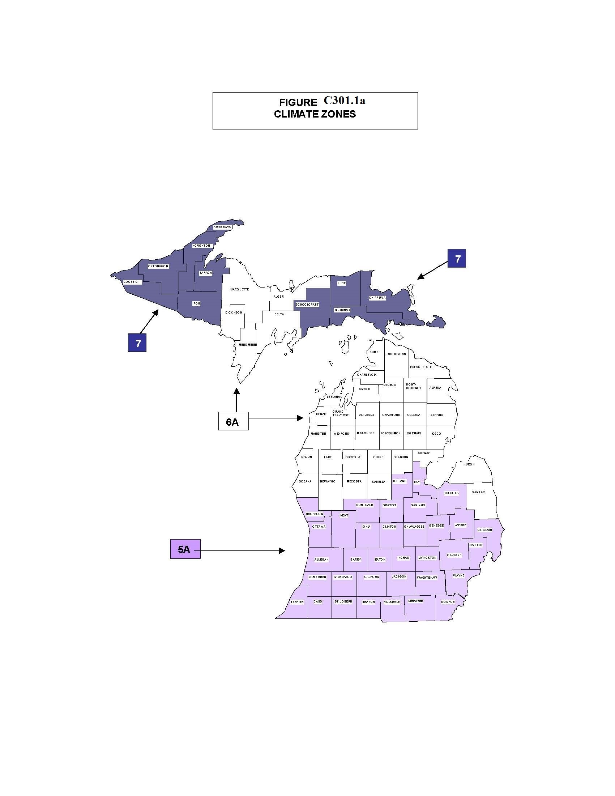

R 408.31097 Fenestration product rating. Rescinded.
Rule 1097. Section C303.1.3 of the code is amended to read as follows:
C303.1.3. Fenestration product rating. U-factors or fenestration products (windows, doors, and skylights) shall be determined in accordance with NFRC 100 by an accredited, independent laboratory, and labeled and certified by the manufacturer. Products lacking a labeled U-factor shall be assigned a default U-factor from Table C303.1.3(1) or C303.1.3(2).
Exception:
1. Computer simulations by independent NFRC certified laboratories or approval under the Stille-Derossett-Hale Single State Construction Code Act, 1972 PA 230, MCL 125.1501 to 125.1531, is considered in compliance with this section.
2. Where required, garage door U-factors shall be determined in accordance with either NFRC 100 or ANSI/DASMA 105.
U-factors shall be determined by an accredited, independent laboratory, and labeled and certified by the manufacturer.
Products lacking a labeled U-factor shall be assigned a default U-factor from Table C303.1.3(1) or C303.1.3(2). The solar heat gain coefficient (SHGC) and visible transmittance (VT) of glazed fenestration products (windows, glazed doors, and skylights) shall be determined in accordance with NFRC 200 by an accredited, independent laboratory, and labeled and certified by the manufacturer. Products lacking such a labeled SHGC or VT shall be assigned a default SHGC or VT from table C303.1.3(3).

R 408.31098 (C506.1) Envelope alterations. Rescinded.
Rule 1098. Section 5.1.3 of the standard is amended to read as follows:
(5.1.3). Alterations to the building envelope shall comply with the requirements of section 5 for insulation, air leakage, and fenestration applicable to those specific portions of the building that are being altered.
Exceptions:
1. Installation of storm windows or glazing panels over existing glazing, provided the storm window or glazing panel contains a low-emissivity coating. However, a low-emissivity coating is not required where the existing glazing already has a low-emissivity coating. Installation may be either on the inside or outside of the existing glazing.
2. Replacement of glazing in existing sash and frame, provided the U-factor and SHGC will be equal to or lower than before the glass replacement.
3. Alterations to roof or ceiling, wall, or floor cavities that are insulated to full depth with insulation having a minimum nominal value of R-3.0/in.
4. Alterations to walls and floors, where the existing structure is without framing cavities and no new framing cavities are created.
5. Roof recovering.
6. Removal and replacement of a roof membrane where there is existing roof insulation integral to or below the roof deck.
7. Removal and replacement of a roof membrane where the insulation is installed entirely above the roof deck, a minimum of R-20 insulation shall be permitted where the placement of additional insulation greater than R-20 insulation would require either of the following:
a. Raising the height of parapets, weep systems, or through wall flashings where roof abuts adjoining walls or parapets.
b. Raising the height of mechanical or electrical equipment, mechanical curbs, roof hatches, skylight curbs, service equipment, piping, conduit, duct work, roof platforms, ladders, stairs, guard rails, expansion joints, roof davits, or door thresholds.
8. Replacement of existing fenestration, provided that the area of the replacement fenestration does not exceed 25% of the total fenestration area of an existing building and that the U-factor and SHGC, will be equal to or lower than before the fenestration replacement.

R 408.31098a (C506.2) Vestibules. Rescinded.
Rule 1098a. Section 5.4.3.4 of the standard is amended to reads as follows:
5.4.3.4. Vestibules. Building entrances that separate conditioned space from the exterior shall be protected with an enclosed vestibule, with all doors opening into and out of the vestibule equipped with self-closing devices. Vestibules shall be designed so that in passing through the vestibule it is not necessary for the interior and exterior doors to open at the same time. Interior and exterior doors shall have a minimum distance between them of not less than 7 feet when in the closed positon. The floor area of each vestibule shall not exceed the greater of 50 feet² or 2% of the gross conditioned floor area for that level of the building. The exterior envelope of conditioned vestibules shall comply with the requirements for a conditioned space. The interior and exterior envelope of unconditioned vestibules shall comply with the requirements for a semiheated space.
Exceptions:
1. Doors not intended to be used by the public, such as doors to storage, mechanical, electrical, or equipment rooms.
2. Doors opening directly from a sleeping unit or dwelling unit.
3. Doors that open directly from a space less than 3,000 feet² (298 m²) in area.
4. Revolving doors.
5. Doors used primarily to facilitate shipping, receiving, or material handling.
6. Doors with no exterior entrance hardware.
7. Doors leading solely to outdoor eating areas.
8. Overhead doors.

R 408.31098b (C506.3) System commissioning. Rescinded.
R1098a. Section 6.7.2.4 of the standard is amended to read as follows:
6.7.2.4. System Commissioning. HVAC control systems shall be tested to ensure that control elements are calibrated, adjusted, and in proper working condition. For projects larger than 10,000 ft², conditioned area, except warehouses and semiheated spaces, detailed instructions for commissioning HVAC systems (see informative appendix E) shall be provided by the designer in plans and specifications.

R 408.31098c (C506.4) Lighting alterations.
Rule 1098b. Section 9.1.2 of the standard is amended to read as follows:
9.1.2. Lighting alterations. For the alteration of any lighting system in an interior space, that space shall comply with the lighting power density, (LPD), requirements allowances of section 9 9.5.1 or 9.6.1 and the control requirements of section applicable to that space and the automatic shutoff requirements of section 9.4.1.1 (a) to (d) and (g) to (i) as applicable to that space. For the alteration of any lighting system for the in an exterior of a building application, that lighting system shall comply with the LPD lighting power density (LPD) requirements allowances of section 9 9.4.2 applicable to the area illuminated by that lighting system and the applicable control requirements of sections 9.4.1.4(a) and 9.4.1.4(b) and 9.4.2. These alterations shall include all luminaires that are added, replaced, or removed. This requirement shall also be met for alterations that involve only the replacement of lamps plus ballasts. Alterations do not include routine maintenance or repair situations.
Exception: Alterations that involve less than 50% or less of the connected lighting load in a space or area need not comply do not have to comply with these requirements, provided that such the alterations do not increase the installed LPD lighting power.

