DEPARTMENT OF AGRICULTURE
AND RURAL DEVELOPMENT

PESTICIDE AND PLANT PEST MANAGEMENT DIVISION

REGULATION NO. 637. PESTICIDE USE

Filed with the secretary of state on

These rules take effect immediately upon filing with the secretary of state unless adopted under section 33, 44, or 45a(6) of the administrative procedures act of 1969, 1969 PA 306, MCL 24.233, 24.244, or 24.245a. Rules adopted under these sections become effective 7 days after filing with the secretary of state.

(By authority conferred on the director of the department of agriculture and rural development by section 8325 of the natural resources and environmental protection act, 1994 PA 451, MCL 324.8325)

R 285.637.11 of the Michigan Administrative Code is amended, as follows:

R 285.637.11 Commercial notification and posting requirements.
Rule 11. (1) The requirements of this rule shall not apply to general-use ready-to-use pesticide.
(2) When making a broadcast, foliar, or space application of pesticides to an ornamental or turf site, other than a golf course or farm production operation, a commercial applicator shall comply with both of the following provisions:
(a) In addition to requirements specified in R 285.637.12(1) and (2), an applicator shall inform a customer that lawn markers should remain posted for 24 hours, after which time the customer should remove the lawn markers.
(b) Immediately following the application, a commercial applicator shall place a lawn marker sign at the primary point or points of entry. Lawn markers specified in subrule (2) of this rule shall only be used when making pesticide applications and shall be in compliance with all of the following specifications:
(i) Be 4 inches high by 5 inches wide.
(ii) Be constructed of rigid, weather-resistant material.
(iii) Be attached to a supporting device with the bottom of the marker extending not less than 12 inches above the turf.
(iv) Be identically printed on both sides in green letters on a white background using the indicated point type size.
(v) Include only the following information:
(A) The statement "CAUTION" in 11/16-inch high (72-point) type.
(B) The statement "Pesticide Application" in 9/32-inch (30-point) type.
(C) The statement "Keep Off Until Dry" in 9/32-inch (30-point) type.
(D) Have not less than a 2-inch diameter circular illustration that depicts an adult and child walking a dog on a leash. The illustration shall depict, using a diagonal line across the circle, that this action is prohibited.
(E) The statement "Customer: Please Remove After 24 Hours" in 3/32-inch (11-point) type.
(F) Additional information not required under subrule (2) of this rule may only be placed on the lawn marker or supporting device with the written approval of the department.
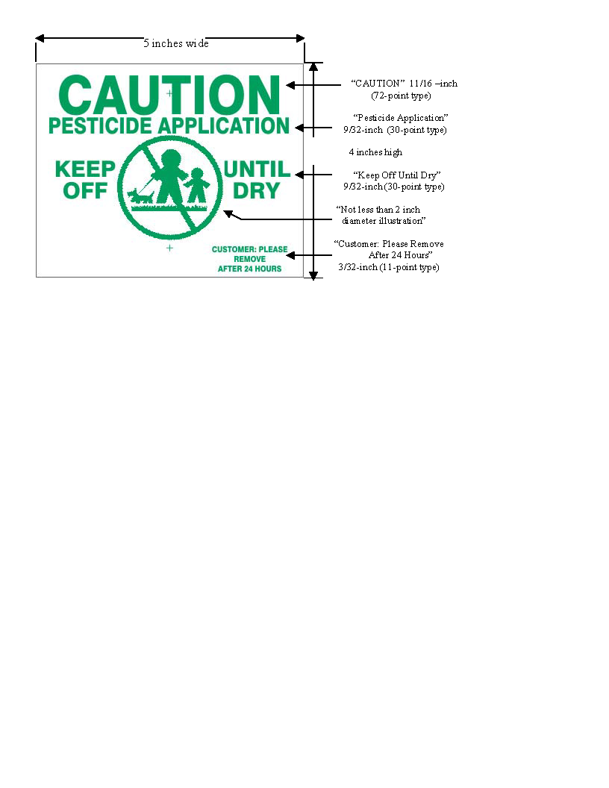

(3) All broadcast, foliar, or space pesticide applications that are made to public or private golf courses by a commercial applicator shall be in compliance with all of the following provisions:
(a) Applicators shall notify users of, or visitors to, the golf course in accordance with all of the following requirements:
(i) Notification of pesticide application shall be provided on a poster or placard that is constructed of all-weather material.
(ii) The poster or placard shall contain a general statement that from time to time pesticides are in use in the management of turf and ornamental pests.
(iii) The poster or placard shall state that questions or concerns that arise in relation to the pesticide application shall be directed to the golf course superintendent or his or her designated representative.
(iv) The poster or placard shall state that, upon request, the superintendent or his or her representative will supply the information specified in subdivision (b) of this subrule.
(v) The poster or placard shall be displayed prominently in the pro shop, locker rooms, or registration area.
(b) At the time of broadcast, foliar, or space pesticide application to golf course property, the applicator shall post, on the first and tenth tees, in a conspicuous place, a sign that states all of the following information:
(i) The date and time of application.
(ii) The common name of the pesticide applied.
(iii) The areas treated.
(iv) The label reentry precautions.
(v) The name of a person who may be contacted for further information.
(c) Posting requirements shall remain in effect until specific label reentry requirements have been fulfilled.
(4) A commercial applicator who makes a broadcast, foliar, or space insecticide application in a commercial building, public building, or health care facility shall comply with all of the following:
(a) The applicator shall, upon completion of an insecticide application, provide a sign to be displayed in a readily observable place at the primary point of entry by the building manager.
(b) The applicator shall instruct the building manager that the sign must be displayed and remain posted for not less than 48 hours after the most recent application of an insecticide.
(c) The building manager shall post all signs provided by the applicator in accordance with this subrule.
(d) Signs that are used for posting shall be in compliance with the following specifications:
(i) The sign shall be a minimum of 2 1/2 inches high by 2 1/2 inches wide.
(ii) Information shall be in black letters on a muted background.
(iii) The sign shall have an illustration which is not less than 1 3/4 inches high by 2 inches wide and which depicts a cloud symbol encompassing a house. This illustration shall serve to inform the public that insecticides have been applied in the building.
(iv) The sign shall have a space provided in which the date of application is to be indicated by the applicator. This information shall read: "DATE _______________" in a minimum 1/8-inch (16-point) type.
(5) All of the following provisions apply to notification requirements for community or right-of-way applicators:
(a) A commercial applicator shall not make a broadcast or foliar application of pesticides for community or right-of-way pest management without making documented efforts to provide prior notification to persons who own or reside on property that is within the target area or to their authorized representatives. Prior notification shall be provided by the commercial applicator or his or her agent.
(b) Documented efforts to notify property owners, their agents, or persons who own or reside on property that is within the target area for community mosquito control pesticide applications include at least 1 of the following methods:
(i) Personal contact.
(ii) A comprehensive community outreach program, which shall be filed annually with the director.
(iii) Prior written notification.
(c) Commercial applicators who make community pesticide applications for mosquito control shall do all of the following:
(i) Provide prior notification to persons who request it.
(ii) Exclude mosquito pesticide applications from the property of those persons who request to be excluded.
(iii) Provide general information or literature about the pesticide application in response to inquiries within the targeted community. This does not include any proprietary or confidential business information.
(d) Reasonable efforts to notify property owners, their agents, or persons residing within the target area for right-of-way or community pesticide applications other than those for mosquito control shall include at least 1 of the following methods:
(i) Personal contact.
(ii) Advertisement in at least 1 newspaper of general circulation within the area of application. The notice shall be placed in the legal advertisement section.
(iii) Prior written notification.
(e) Notification of property owners shall include all the following information:
(i) The name, address, and phone number of the application firm or individual.
(ii) The brand name and active ingredients of the pesticide or pesticides used.
(iii) The method of application.
(iv) The scheduled date or dates of application.
(v) The name, address, and phone number of a person who may be contacted and who is responsible for supplying updated information concerning the application for those people who request it.
(vi) Any reentry restrictions.
(f) Multiple-use areas shall be posted for not less than 24 hours at the primary point or points of entry immediately after a pesticide application has occurred within the area. The posting shall state all of the following information:
(i) The name, address, and phone number of the application firm or individual.
(ii) The brand name and active ingredients of the pesticide or pesticides used.
(iii) The date of the application.
(iv) Precautionary warnings or reentry restrictions that appear on the label of the pesticide or pesticides that are applied.
(g) Upon petition, the director may exempt community or area-wide applicators from the requirements of subdivision (f) of this subrule if there is sufficient documentation to indicate that residues of a particular pesticide are not detectable after application.
(h) Notification requirements shall be waived in the event of a public health emergency as determined by the Michigan department of community health. Upon a determination by the director of the Michigan department of health and human services that an imminent danger to the health or lives of individuals exists in this state, the director shall cooperate and provide assistance and recommendations to eliminate or mitigate the danger. The director may waive or modify notification and exclusion requirements of this rule to facilitate response.

