DEPARTMENT OF ATTORNEY GENERAL

PUBLIC ADMINISTRATION DIVISION

FINANCIAL EXPLOITATION PREVENTION ACT

Filed with the secretary of state on

These rules take effect immediately upon filing with the secretary of state unless adopted under section 33, 44, or 45a(9) of the administrative procedures act of 1969, 1969 PA 306, MCL 24.233, 24.244, or 24.245a. Rules adopted under these sections become effective 7 days after filing with the secretary of state.

(By authority conferred on the department of attorney general by section 5 of the financial exploitation prevention act, 2020 PA 344, MCL 487.2085)
R 14.21, R 14.22, R 14.23, R 14.24, R 14.25, R 14.26, R 14.27, R 14.28, and R 14.29 are added to the Michigan Administrative Code, as follows:

R 14.21 Definitions.
Rule 21. As used in these rules:
(a) “Act” means the financial exploitation prevention act, 2020 PA 344, MCL 487.2081 to 487.2091.
(b) “County prosecutor” means the duly elected or appointed county prosecutor, or the county prosecutor’s designee.
(c) Terms defined in the act have the same meanings when used in these rules.

R 14.22 Notification to county prosecutor by adult protective services; content.
Rule 22. The notification to the county prosecutor by adult protective services must:
(a) Be provided in writing.
(b) Be provided on a form titled “FEPA Adult Protective Services or Law Enforcement Notice to Prosecutor.”
(c) Include a written report prepared by an adult protective services employee with the form.
(d) Include the name and contact information for the adult protective services employee in charge of the investigation.
(e) Include a copy of the financial institution’s report submitted to or committed to written form by adult protective services.
(i) When the report from the financial institution is committed to written form by an adult protective services employee, the report from the financial institution may be contained within the report prepared by the adult protective services, and need not be submitted as an additional report.
(f) Include a description of the response to or actions taken by adult protective services based on the report from the financial institution.
(g) Include names and contact information of individuals that possess information about the alleged covered financial exploitation within a written report prepared by an adult protective services employee.
(h) Include a summary or brief description of the alleged covered financial exploitation if not contained in any report attached to the form titled “FEPA Adult Protective Services or Law Enforcement Notice to Prosecutor.”

R 14.23 Notification to county prosecutor by law enforcement; content.
Rule 23. The notification to the county prosecutor by law enforcement must:
(a) Be provided in writing.
(b) Be provided on a form titled “FEPA Adult Protective Services or Law Enforcement Notice to Prosecutor.”
(c) Include a written report prepared by a law enforcement officer.
(d) Include the name of the law enforcement agency and the name and contact information of the officer in charge of the investigation.
(e) Include a copy of the financial institution’s report submitted to or committed to written form by the law enforcement agency.
(f) Include a description of the response to or actions taken by law enforcement based on the report from the financial institution.
(g) Include names and contact information of individuals that possess information about the alleged covered financial exploitation within a written report prepared by a law enforcement officer.
(h) Include a summary or brief description of the alleged covered financial exploitation if not contained in any report attached to the form titled “FEPA Adult Protective Services or Law Enforcement Notice to Prosecutor.”

R 14.24 Notification to county prosecutor by financial institutions; content.
Rule 24. The notification to the county prosecutor by a financial institution must:
(a) Be provided in writing.
(b) Be submitted on a form titled “FEPA Financial Institution Notice to Prosecutor.” Supporting documentation may be attached to the form by the financial institution.
(c) Include a description of efforts by the financial institution to contact law enforcement or adult protective services, and an indication of whether any contact has been made.
(d) Include a description of whether any contact has previously been made with the county prosecutor’s office regarding this same matter.
(e) Indicate whether written notification was received from law enforcement or adult protective services stating whether the reported alleged covered financial exploitation is under investigation or has been referred to law enforcement, within 10 business days after a financial institution employee made a report of alleged covered financial exploitation to law enforcement or adult protective services.
(f) Include the name and contact information for the financial institution’s designated contact for communication with the county prosecutor, law enforcement, or adult protective services.
(g) Include the name and contact information of the alleged perpetrator, if that information is known by the financial institution making the report.
(h) Include the name and contact information of the alleged victim, if known by the financial institution making the report.
(i) Include a description of the relationship between the alleged perpetrator and the victim, if known by the financial institution making the report.

R 14.25 Notification to county prosecutor; determining county of contact.
Rule 25. The financial institution shall use the following sequential steps to determine the appropriate prosecutor to contact:
(a) Contact adult protective services or law enforcement as follows:
(i) To contact adult protective services, a financial institution shall call the 24-hour intake telephone line maintained by the department of health and human services to contact adult protective services to provide notification under the act. If adult protective services develops other contact methods, utilizing those contact methods complies with these rules.
(ii) To contact law enforcement, if the victim’s county of residence is known, the financial institution shall contact law enforcement in the county of the victim’s residence. If the victim’s county of residence is unknown, the financial institution shall contact law enforcement in the county in which the alleged covered financial exploitation was observed, or in the county where the financial institution is located if the alleged covered financial exploitation took place in another state. The financial institution may also contact law enforcement in the county in which the alleged covered financial exploitation is observed, regardless of the victim’s county of residence, if the alleged covered financial exploitation is actively taking place on-site at the financial institution.
(A) The financial institution shall contact law enforcement by calling the central dispatch office in the county in which law enforcement is to be notified, or by making a written report if the central dispatch office has the capability to accept written reports as follows:
(1) The financial institution shall dial 911 to contact central dispatch if the matter is determined to be an emergency by the financial institution, or if the alleged covered financial exploitation is actively taking place on-site at the financial institution at the time the contact is being made.
(2) If the matter is determined not to be an emergency by the financial institution and is not actively taking place on-site at the financial institution, the financial institution shall call the non-emergency telephone number for central dispatch or make a written report if the central dispatch office has the capability to accept written reports. If central dispatch has the capability to accept written reports, the financial institution may make the written report to central dispatch by emailing, faxing, or hand-delivering a written report.
(b) Contact the county prosecutor as follows:
(i) If the financial institution has been unable to contact adult protective services or law enforcement to provide notification under the act, the financial institution shall determine if the victim’s county of residence is known and do 1 of the following:
(A) If the victim’s county of residence is known, the financial institution shall contact the prosecutor in the county of the victim’s residence.
(B) If the victim’s county of residence is unknown, the financial institution shall contact the prosecutor in the county in which the alleged covered financial exploitation was observed, or in the county where the financial institution is located if the alleged covered financial exploitation took place in another state.
(ii) If the financial institution employee has contacted adult protective services, the financial institution shall contact the county prosecutor’s office in the county in which the assigned adult protective services employee is stationed, if known by the financial institution. If the financial institution does not know where the adult protective services employee is stationed, the financial institution shall determine if the victim’s county of residence is known and do 1 of the following:
(A) If the victim’s county of residence is known, the financial institution shall contact the prosecutor in the county of the victim’s residence.
(B) If the victim’s county of residence is unknown, the financial institution shall contact the prosecutor in the county in which the alleged covered financial exploitation was observed, or in the county where the financial institution is located if the alleged covered financial exploitation took place in another state.
(iii) If the financial institution has contacted law enforcement, the financial institution shall contact the county prosecutor’s office in the county in which the assigned law enforcement officer is stationed, if known by the financial institution. If the financial institution does not know where the law enforcement officer is stationed, the financial institution shall determine if the victim’s county of residence is known and do 1 of the following:
(A) If the victim’s county of residence is known, the financial institution shall contact the prosecutor in the county of the victim’s residence.
(B) If the victim’s county of residence is unknown or cannot be determined, the financial institution shall contact the prosecutor in the county in which the alleged covered financial exploitation was observed, or in the county where the financial institution is located if the alleged covered financial exploitation took place in another state.

R 14.26 Notification to county prosecutor by adult protective services, law enforcement,
and financial institutions; obtaining contact information.
Rule 26. The contact information for the county prosecutor’s office shall be obtained by adult protective services, law enforcement, and financial institutions by referencing an electronic directory compiled by the Prosecuting Attorneys Association of Michigan (PAAM) that is available on PAAM’s website. This directory will include the name and contact information for the contact designated to receive notifications under the act at each county prosecutor’s office, and the primary phone number for the county prosecutor’s office. If unable to contact the specific employee listed in the directory, the financial institution should contact the office of the county prosecutor using the primary phone number for the office and request instruction for sending the written notification required under the act.

R 14.27 Notification to county prosecutor adult protective services, law enforcement, and financial institutions; method of contact.
Rule 27. The notifications under the act to the county prosecutor’s office must be made as follows:
(a) Be in writing.
(b) Be made using the form referenced in these rules.
(c) Be delivered to the county prosecutor’s office by email, fax, or by in-person delivery. If the contact is made by email or by fax, the agency or financial institution making the report shall request an acknowledgement of receipt.
(d) When notification is made to the county prosecutor’s office by a law enforcement agency, reports should be made by any law enforcement agency that receives a copy of a notification of alleged covered financial exploitation by a financial institution under the act.
(e) When notification is made to the county prosecutor’s office by the financial institution, a copy of the notification may, but is not required to be, sent by the financial institution to the department of attorney general.

R 14.28 Notification to county prosecutor by adult protective services or law
enforcement; form.
Rule 28. The purpose of this rule is to prescribe the form of the notification to the county prosecutor by adult protective services or law enforcement as required by the act.
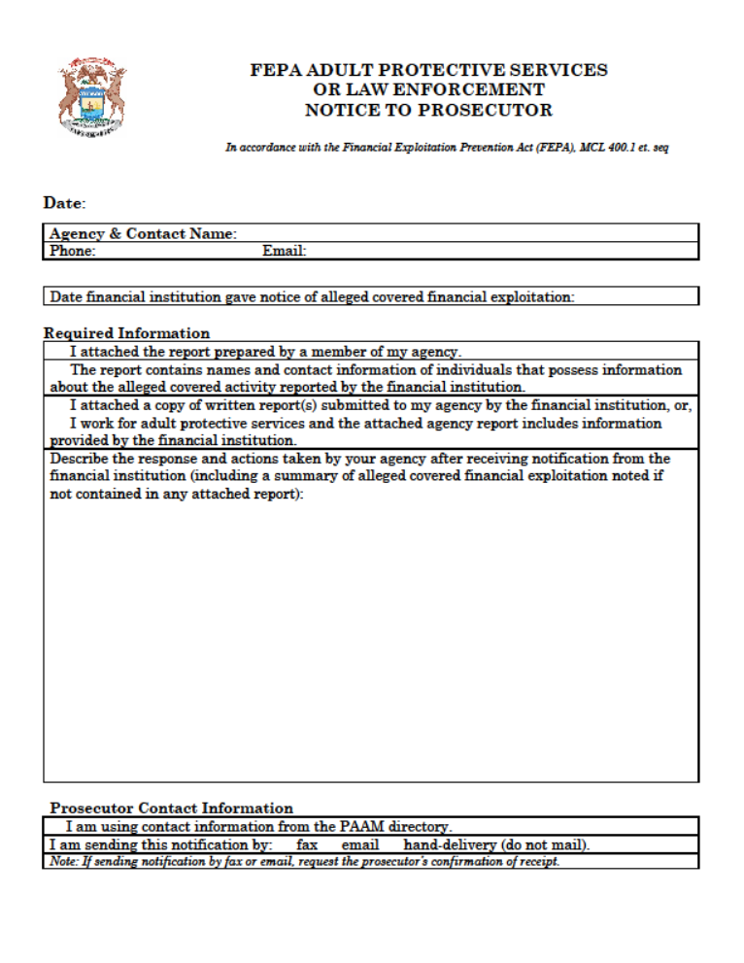
R 14.29 Notification to county prosecutor by financial institution; form.
Rule 29. The purpose of this rule is to prescribe the form of the notification to the county prosecutor by the financial institution as required by the act.

