DEPARTMENT OF ATTORNEY GENERAL

FINANCIAL CRIMES DIVISION

UNIFORM SECURITIES ACT (2002) MANDATORY REPORTING OF FINANCIAL EXPLOITATION

Filed with the secretary of state on

These rules become effective immediately after filing with the secretary of state unless adopted under section 33, 44, or 45a(9) of the administrative procedures act of 1969, 1969 PA 306, MCL 24.233, 24.244, or 24.245a. Rules adopted under these sections become effective 7 days after filing with the secretary of state.

(By authority conferred on the department of attorney general by section 535 of the uniform securities act (2002), 2008 PA 551, MCL 451.2535)
R 14.31, R 14.32, R 14.33, R 14.34, R 14.35, R 14.36, R 14.37, R 14.38, and R 14.39 are added to the Michigan Administrative Code, as follows:

R 14.31 Definitions.
Rule 31. (1) As used in these rules:
(a) “Act” means article 5A of the uniform securities act (2002), 2008 PA 551, MCL 451.2531 to 451.2543.
(b) “County prosecutor” means the duly elected or appointed county prosecutor, or the county prosecutor’s designee.
(2) Terms defined in the act have the same meanings when used in these rules.

R 14.32 Notification to county prosecutor by adult protective services; content.
Rule 32. The notification to the county prosecutor by adult protective services must comply with all of the following:
(a) Be provided in writing.
(b) Be provided on a form titled “Uniform Securities Act Adult Protective Services or Law Enforcement Notice to Prosecutor.” A notification provided on a substitute form titled, “FEPA Adult Protective Services or Law Enforcement Notice to Prosecutor” also complies with this rule.
(c) Include a written report prepared by an adult protective services employee.
(d) Include the name and contact information for the adult protective services employee in charge of the investigation.
(e) Include a copy of the broker-dealer’s or investment adviser’s report submitted to or committed to written form by adult protective services. If the report from the broker-dealer or investment adviser is committed to written form by an adult protective services employee, the report from the broker-dealer or investment adviser may be contained within the report prepared by adult protective services and need not be submitted as an additional report.
(f) Include a description of the response to or actions taken by adult protective services based on the report from the broker-dealer or investment adviser.
(g) Include names and contact information of individuals who possess information about the alleged covered financial exploitation within a written report prepared by an adult protective services employee.
(h) Include a summary or brief description of the alleged covered financial exploitation if not contained in any report attached to the form titled “Uniform Securities Act Adult Protective Services or Law Enforcement Notice to Prosecutor.”

R 14.33 Notification to county prosecutor by law enforcement; content.
Rule 33. The notification to the county prosecutor by law enforcement must comply with all of the following:
(a) Be provided in writing.
(b) Be provided on a form titled “Uniform Securities Act Adult Protective Services or Law Enforcement Notice to Prosecutor.” A notification provided on a substitute form titled, “FEPA Adult Protective Services or Law Enforcement Notice to Prosecutor” also complies with this rule.
(c) Include a written report prepared by a law enforcement officer.
(d) Include the name of the law enforcement agency and the name and contact information of the officer in charge of the investigation.
(e) Include a copy of the broker-dealer’s or investment adviser’s report submitted to or committed to written form by the law enforcement agency.
(f) Include a description of the response to or actions taken by law enforcement based on the report from the broker-dealer or investment adviser.
(g) Include names and contact information of individuals who possess information about the alleged covered financial exploitation within a written report prepared by a law enforcement officer.
(h) Include a summary or brief description of the alleged covered financial exploitation if not contained in any report attached to the form titled “Uniform Securities Act Adult Protective Services or Law Enforcement Notice to Prosecutor.”

R 14.34 Notification to county prosecutor by broker-dealers or investment advisers;
content.
Rule 34. If a broker-dealer or investment adviser elects to notify the county prosecutor as allowed by section 535 of the act, MCL 451.2535, the notification to the county prosecutor by a broker-dealer or investment adviser must comply with all of the following:
(a) Be provided in writing.
(b) Be submitted on a form titled “Uniform Securities Act Broker-Dealer or Investment Adviser Notice to Prosecutor.” Supporting documentation may be attached to the form by the broker-dealer or investment adviser.
(c) Include a description of efforts by the broker-dealer or investment adviser to contact law enforcement or adult protective services, and an indication of whether any contact was made.
(d) Include a description of whether any contact has previously been made with the county prosecutor’s office regarding this matter.
(e) Indicate whether written notification was received from law enforcement or adult protective services stating whether the reported alleged covered financial exploitation is under investigation or was referred to law enforcement, within 15 business days after a broker-dealer or investment adviser made a report of alleged covered financial exploitation to law enforcement or adult protective services.
(f) Include the name and contact information for the broker-dealer or investment adviser’s designated contact for communication with the county prosecutor, law enforcement, or adult protective services.
(g) Include the name and contact information of the alleged perpetrator, if that information is known by the broker-dealer or investment adviser making the report.
(h) Include the name and contact information of the alleged victim, if known by the broker-dealer or investment adviser making the report.
(i) Include a description of the relationship between the alleged perpetrator and the victim, if known by the broker-dealer or investment adviser making the report.

R 14.35 Notification to county prosecutor; determining county of contact.
Rule 35. If a broker-dealer or investment adviser elects to notify the county prosecutor, the broker-dealer or investment adviser shall use the following sequential steps to determine the appropriate prosecutor to contact:
(a) Contact adult protective services or law enforcement as follows:
(i) To contact adult protective services, a broker-dealer or investment adviser shall call the 24-hour intake telephone line maintained by the department of health and human services to contact adult protective services to provide notification under the act. If adult protective services develops other contact methods, utilizing those contact methods complies with this rule.
(ii) To contact law enforcement, if the victim’s county of residence is known, the broker-dealer or investment adviser shall contact law enforcement in the county of the victim’s residence. If the victim’s county of residence is unknown, the broker-dealer or investment adviser shall contact law enforcement in the county where the alleged covered financial exploitation was observed, or in the county where the broker-dealer or investment adviser is located if the alleged covered financial exploitation took place in another state. The broker-dealer or investment adviser may also contact law enforcement in the county where the alleged covered financial exploitation is observed, regardless of the victim’s county of residence, if the alleged covered financial exploitation is actively taking place in the presence of the broker-dealer or investment adviser. The broker-dealer or investment adviser shall contact law enforcement by calling the central dispatch office in the county where law enforcement is to be notified, or by making a written report if the central dispatch office has the capability to accept written reports, as follows:
(A) The broker-dealer or investment adviser shall dial 911 to contact central dispatch if the matter is determined to be an emergency by the broker-dealer or investment adviser or if the alleged covered financial exploitation is actively taking place in the presence of the broker-dealer or investment adviser at the time the contact is being made.
(B) If the matter is determined not to be an emergency by the broker-dealer or investment adviser and is not actively taking place in the presence of the broker-dealer or investment adviser, the broker-dealer or investment adviser shall call the non-emergency telephone number for central dispatch or make a written report if the central dispatch office has the capability to accept written reports. If central dispatch has the capability to accept written reports, the broker-dealer or investment adviser may make the written report to central dispatch by emailing, faxing, or hand-delivering a written report.
(b) Contact the county prosecutor as follows:
(i) If the broker-dealer or investment adviser is unable to contact adult protective services or law enforcement to provide notification under the act and if the broker-dealer or investment adviser elects to notify the county prosecutor, the broker-dealer or investment adviser shall determine if the victim’s county of residence is known and do 1 of the following:
(A) If the victim’s county of residence is known to the broker-dealer or investment adviser, the broker-dealer or investment adviser shall contact the prosecutor in the county of the victim’s residence.
(B) If the victim’s county of residence is unknown to the broker-dealer or investment adviser, the broker-dealer or investment adviser shall contact the prosecutor in the county where the alleged covered financial exploitation was observed, or in the county where the broker-dealer or investment adviser is located if the alleged covered financial exploitation took place in another state.
(ii) If the broker-dealer or investment adviser has contacted adult protective services, the broker-dealer or investment adviser shall contact the county prosecutor’s office in the county where the assigned adult protective services employee is stationed, if known by the broker-dealer or investment adviser. If the broker-dealer or investment adviser does not know where the adult protective services employee is stationed, the broker-dealer or investment adviser shall determine if the victim’s county of residence is known and do 1 of the following:
(A) If the victim’s county of residence is known to the broker-dealer or investment adviser, the broker-dealer or investment adviser shall contact the prosecutor in the county of the victim’s residence.
(B) If the victim’s county of residence is unknown or cannot be determined by the broker-dealer or investment adviser, the broker-dealer or investment adviser shall contact the prosecutor in the county where the alleged covered financial exploitation was observed, or in the county where the broker-dealer or investment adviser is located if the alleged covered financial exploitation took place in another state.
(iii) If the broker-dealer or investment adviser has contacted law enforcement, the broker-dealer or investment adviser shall contact the county prosecutor’s office in the county where the assigned law enforcement officer is stationed, if known by the broker-dealer or investment adviser. If the broker-dealer or investment adviser does not know where the law enforcement officer is stationed, the broker-dealer or investment adviser shall determine if the victim’s county of residence is known and do 1 of the following:
(A) If the victim’s county of residence is known to the broker-dealer or investment adviser, the broker-dealer or investment adviser shall contact the prosecutor in the county of the victim’s residence.
(B) If the victim’s county of residence is unknown or cannot be determined by the broker-dealer or investment adviser, the broker-dealer or investment adviser shall contact the prosecutor in the county where the alleged covered financial exploitation was observed, or in the county where the broker-dealer or investment adviser is located if the alleged covered financial exploitation took place in another state.

R 14.36 Notification to county prosecutor by adult protective services, law enforcement,
and broker-dealer or investment adviser; obtaining contact information.
Rule 36. The contact information for the county prosecutor’s office must be obtained by adult protective services, law enforcement, and broker-dealers or investment advisers by referencing an electronic directory compiled by the Prosecuting Attorneys Association of Michigan (PAAM) that is available on PAAM’s website. This directory includes the name and contact information for the contact designated to receive notifications under the act at each county prosecutor’s office, and the primary phone number for the county prosecutor’s office. If unable to contact the specific employee listed in the directory, the broker-dealer or investment adviser should contact the office of the county prosecutor using the primary phone number for the office and request instruction for sending the written notification required under the act.

R 14.37 Notification to county prosecutor by adult protective services, law enforcement,
and broker-dealers or investment advisers; method of contact.
Rule 37. The notifications under the act to the county prosecutor’s office must comply with all of the following:
(a) Be in writing.
(b) Be made using the forms referenced in these rules.
(c) Be delivered to the county prosecutor’s office by email, fax, or by in-person delivery. If the contact is made by email or by fax, the agency or broker-dealer or investment adviser making the report shall request an acknowledgement of receipt.
(d) When notification is made to the county prosecutor’s office by a law enforcement agency, reports must be made by any law enforcement agency that receives a copy of a notification of alleged covered financial exploitation by a broker-dealer or investment adviser under the act.
(e) When notification is made to the county prosecutor’s office by the broker-dealer or investment adviser, a copy of the notification may be, but is not required to be, sent by the broker-dealer or investment adviser to the department of attorney general.

R 14.38 Notification to county prosecutor by adult protective services or law enforcement;
form.
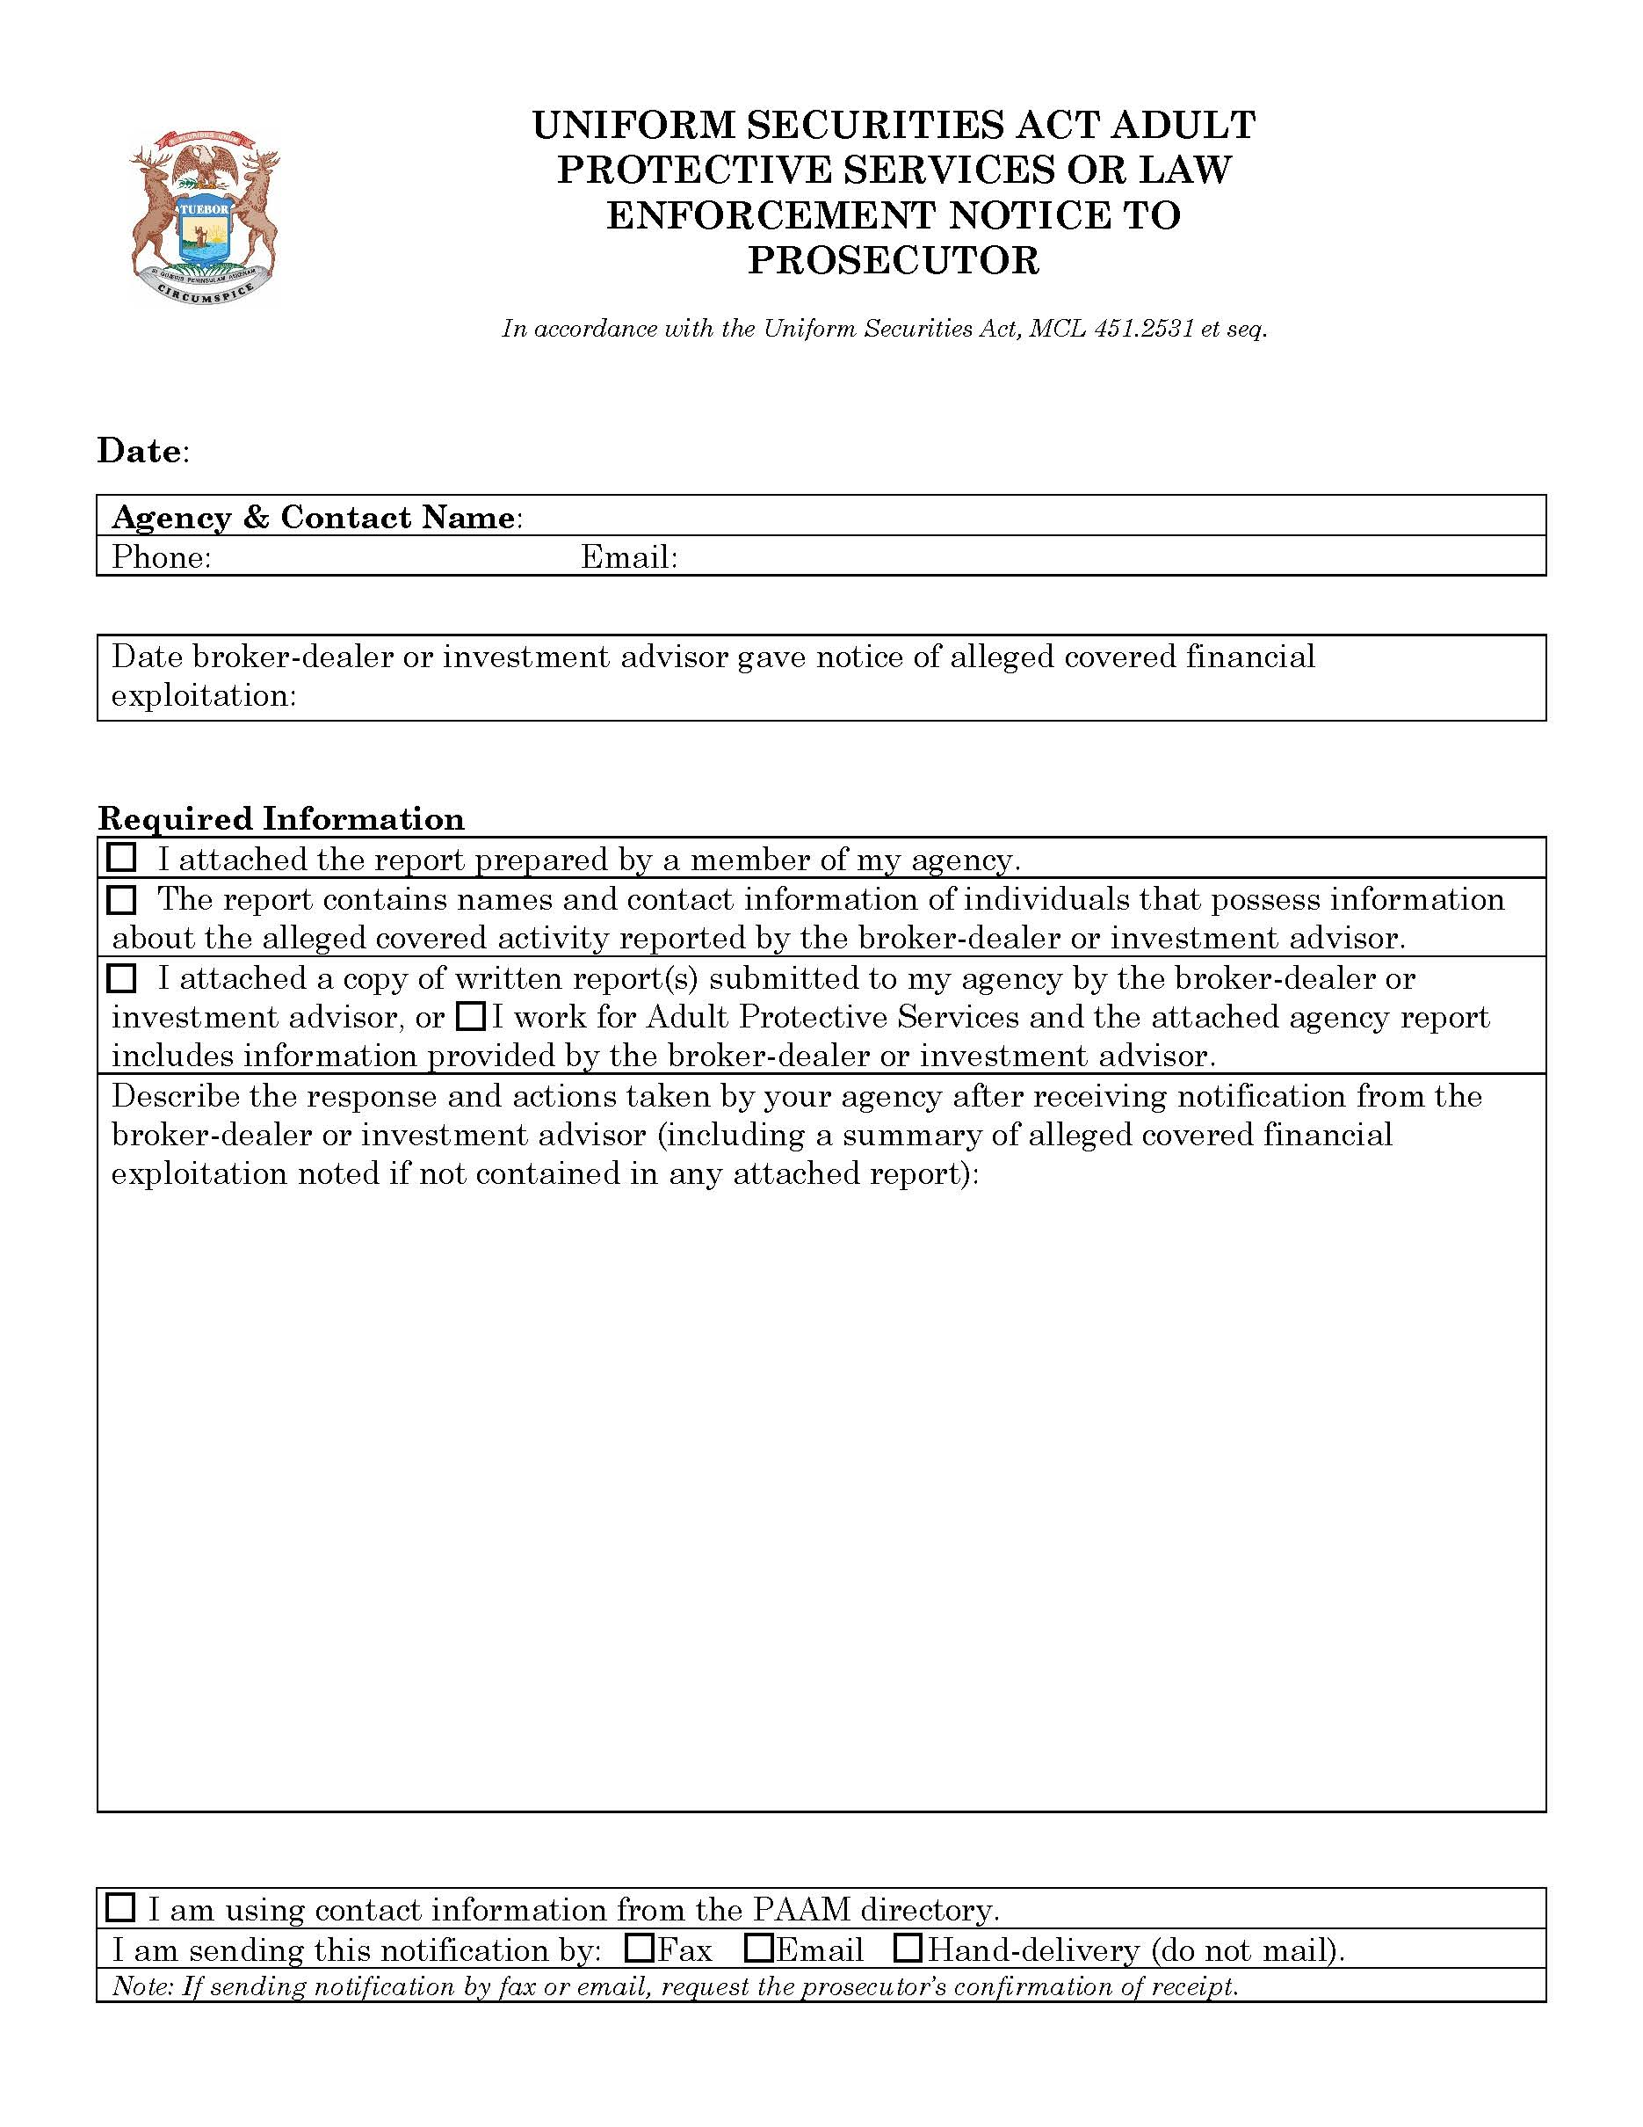
Rule 38. The purpose of this rule is to prescribe the form of the notification to the county prosecutor by adult protective services or law enforcement as required by the act.

R 14.39 Notification to county prosecutor by broker-dealer or investment adviser; form.
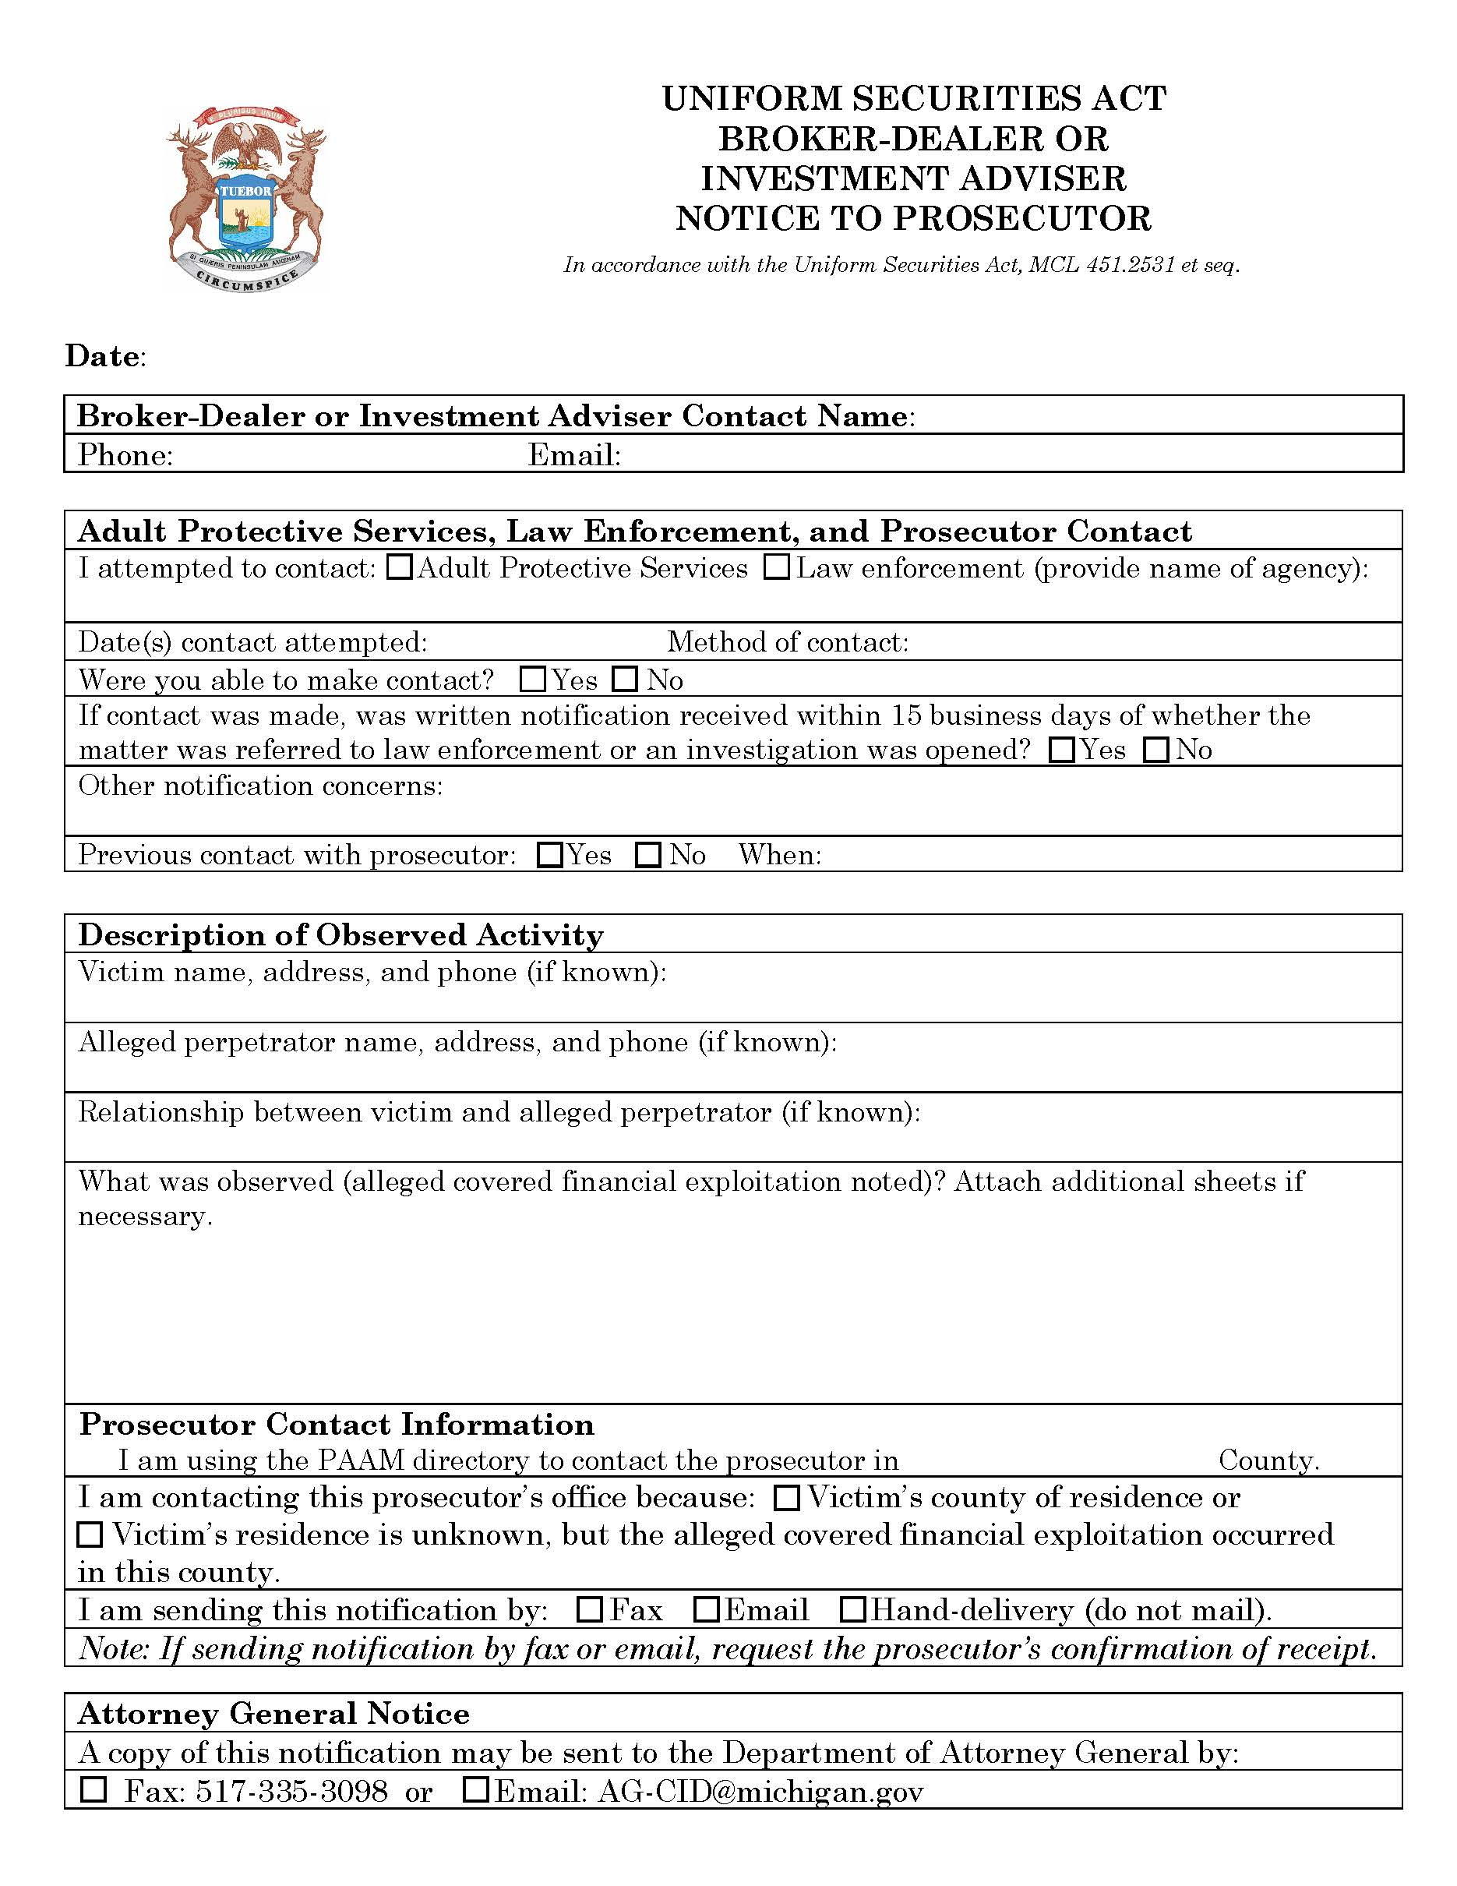
Rule 39. The purpose of this rule is to prescribe the form of the notification to the county prosecutor by the broker-dealer or investment adviser as required by the act.

