

GRETCHEN WHITMER

GOVERNOR

State of Michigan

DEPARTMENT OF HEALTH AND HUMAN SERVICES

Lansing

ELIZABETH HERTEL

DIRECTOR

November 5, 2024

Sent via email to: [JCAR@legislature.mi.gov](mailto:JCAR@legislature.mi.gov)

Joint Committee on Administrative Rules (JCAR) Boji Tower, 3rd Floor

124 W. Allegan St.

P.O. Box 30036

Lansing, MI 48909-7536

Re: Session Day Waiver Request

Dear Chairperson Wojno, Alternate Chairperson Haadsma, and JCAR Committee Members:

As the Regulatory Affairs Officer for the Department of Health and Human Services (Department), I respectfully request that the JCAR waive the remaining session days under the authority provided in the Administrative Procedures Act of 1969, MCL 24.245a(1)(d), for the review of the following rule set:

Universal Blood Lead Testing, Mich Admin Code R 330.301 through R 330.304, (MOAHR No. 2023-74 HS).

The purpose of these rules is to follow the mandate of 2023 PA 146, MCL 333.5474d that includes the requirement the Department to promulgate rules for implementation that requires physicians to test, or order a test, for children for exposure to lead at age 12 and 24 months, or , if no record of a previous test, between 24 and 72 months of age. In addition, the rules require the Department identify those cities and counties of priority where lead poisoning is high.

The Department held a public hearing on the proposed rules on September 23, 2024. The notice of the public hearing was properly published in three statewide newspapers with an extension of any written comments to be provided to the Department by September 27, 2024. There were no appearances at the public hearing. There were five written comments received; two supporting the rules; and the other three with proposed changes where the Department provided clarification to the new rules, with commitment in providing this clarification via new job aids and policy of the new blood testing process. See the attached comment spreadsheet for the issues.

235 SOUTH GRAND AVENUE • PO BOX 30037 • LANSING, MICHIGAN 48909

[www.michigan.gov/mdhhs](http://www.michigan.gov/mdhhs) • 517-241-3740

The waiver is being requested due to the large list of cities and counties, with the corresponding physician and other health facilities in the State that need to begin the blood lead testing on children. The Department is currently working on the implementation of these rules and, because the rules are mandated by statute, to have the process begin around the beginning of calendar year 2025.

For this reason, the Department respectfully asks that the committee waive the balance of the session days in the review period in order for the Department to meet the effective date of the rule set for the start of this new fiscal year.

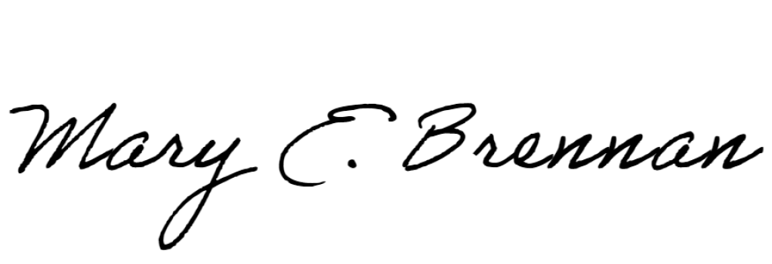Thank you for your consideration of this request.

Sincerely,

Mary E. Brennan Regulatory Affairs Officer

[BrennanM@michigan.gov](mailto:BrennanM@michigan.gov)

Copies to:

Timothy Reeves and Rachel Hughart, Legal Counsel, JCAR Katherine Wienczewski, Director, Michigan Office of Administrative Hearings

and Rules

Chardae Burton, Director, MDHHS Legislative Affairs Administrative Rules Division, [MOAHR-Rules@michigan.gov](mailto:MOAHR-Rules@michigan.gov)

Sarah Lyon-Callo, Senior Deputy Director and State Epidemiologist

2