DEPARTMENT OF STATE

BUREAU OF ELECTIONS

ELECTRONIC VOTING SYSTEMS

Filed with the secretary of state on

These rules become effective immediately after filing with the secretary of state unless adopted under section 33, 44, or 45a(9) of the administrative procedures act of 1969, 1969 PA 306, MCL 24.233, 24.244, or 24.245a. Rules adopted under these sections become effective 7 days after filing with the secretary of state.

(By authority conferred on the secretary of state by sections 31, 794c, and 797b of Act No. 116 of the Public Acts of 1954, being S168.794c of the Michigan Compiled Laws the Michigan election law, 1954 PA 116, MCL 168.31, 168.794c, and 168.797b)

R 168.771, R 168.772, R 168.773, R 168.774, R 168.775, R 168.776, R 168.777, R 168.778, R 168.779, R 168.780, R 168.781, R 168.782, R 168.784, R 168.785, R 168.786, R 168.788, R 168.789, R 168.790, R 168.791, R 168.792, and R 168.793 of the Michigan Administrative Code are amended, R 168.775a and R 168.780a are added, and R 168.783 and R 168.787 are rescinded, as follows:

R 168.771 Definitions.
Rule 1. (1) As used in these rules:
(a) “Absent voter ballot card” means a ballot card attached to a backing that aids a voter to punch out the scored positions on the ballot card. “Absent voter counting board” means an absent voter counting board as described in section 765a of the act, MCL 168.765a.
(b) “Accessible voting device” means a voting device that is accessible for an individual with disabilities as described in section 795(1)(n) of the act, MCL 168.795.
(bc) “Accuracy test” means a test conducted to determine that the program and the computer being used to tabulate the results of the election count the votes in the manner prescribed by the act.
(cd) “Act” means Act No. 116 of the Public Acts of 1954, as amended, being S168.1 et seq. of the Michigan Compiled Laws, and known as the Michigan election law, 1954 PA 116, MCL 168.1 to 168.992.
(e) “Ballot” means an approved paper form or a medium through which votes are recorded that is produced as a paper form.
(f) “Ballot container” means a ballot box, transfer case, or other container used to secure ballots, including optical scan ballots, electronic voting systems, and data during security retention, that is approved by the secretary of state and meets all of the following requirements:
(i) It is made of metal, plastic, fiberglass, or other material that provides resistance to tampering.
(ii) It is capable of being sealed with an approved seal.
(iii) It complies with other requirements described in section 24j of the act, MCL 168.24j.
(d) “Approved computer” means a manufacturer model which has been approved by the board of state canvassers to tabulate ballot cards in this state.
(e) “Ballot card” means a data processing card approved by the board of state canvassers.
(f) “Ballot label assembly” means the assembled unit containing ballot labels and mask.
(g) “Certifying bBoard of election inspectors” means a board consisting of not less than 2 members of differing political party preference which certifies the precinct results on election night of at least 3 inspectors of election as specified in section 672 of the act, MCL 168.672. At least 1 member of the board shall represent each of the 2 major political parties, and these members shall perform approval functions described in the act.
(h) “Chad” means the scored rectangular portion of the ballot card which is punched out of the ballot card by the voter when casting a vote.
(i) “Combination ballot card and write-in ballot” means a ballot card with a separate card attached to it by perforation and which contains instructions and spaces for write-ins. The write-in portion shall be of a size other than that of the ballot card.
(j) “Computer” means 1 or more pieces of automatic tabulating equipment which examines, tabulates, and counts votes recorded on ballot cards or magnetic tapes and prints results.
(k) “Console log” means a listing of the computer responses to program instructions and of instructions to the computer by the operator.
(l) “Correction tape” means a tape designed solely for use in correcting errors on data processing cards.
(h) “Commission” means the commission responsible for the election unless otherwise specified.
(i) “Crossover votes” means votes cast for more than 1 party in an open primary.
(j) “Duplicate ballot” means a ballot on which the word “DUPLICATE” or “DUP” and a number corresponding to the original ballot is printed, stamped, or written that is used to transfer a voter’s valid selections from the original ballot.
(k) “Election equipment” means equipment used in administering elections, including, but not limited to, a voting machine, voting device, or voting system.
(l) “Election management system” means a system that has been approved by the board of state canvassers to produce a program and produce results.
(m) “Election materials” mean materials used in administering elections, including, but not limited to, ballots, physical pollbooks, and other materials described in section 811 of the act, MCL 168.811. Election materials do not include ballot stubs.
(n) “Electronic pollbook” means computer software that receives information from the qualified voter file and is used during elections to process voters and generate reports.
(o) “Overvote” means a combination of votes, including write-in votes, which exceeds the number for which the elector is entitled to vote.
(p) “Physical pollbook” means a paper pollbook in which the election inspectors in a precinct or early voting site shall enter, in the order in which electors are given ballots, the name of each elector who is given a ballot.
(q) “Program” means the operating instructions for a voting system by which it examines, counts, tabulates, and produces the results of the votes cast on a ballot.
(r) “Qualified voter file” means the official file of voters for the conduct of all elections held in this state as described in section 509o of the act, MCL 168.509o.
(s) “Receiving board” means a board consisting of not less than 2 members of differing political party preference that reviews the election materials received from the precinct election inspectors to ensure the election materials are secured and documented properly and the precinct is in balance.
(mt) “Demonstration Sample ballot card” means a ballot card of a distinctive color used to instruct voters on the use of the voting device. The card ballot shall must have the words “DEMONSTRATION SAMPLE BALLOT” printed or stamped on it.
(n) “Demonstrator model” means a voting device on which voters are instructed in the use of the device.
(o) “Duplicate ballot card” means a ballot card on which the word “DUPLICATE” is printed, stamped, or written and which is used to transfer a voter’s valid selections from the original ballot card.
(p) “Edit listing” means a listing showing the names, rotation sequence, and ballot position numbers for each candidate and proposal as they appear in the program for each precinct.
(q) “End card” means a data processing card which instructs the computer that all ballots of a precinct have been counted.
(r) “Header card” means a data processing card which contains the necessary data to identify a precinct to the computer. A header card may be an end card for the preceding precinct.
(s) “Mask” means a piece of material with defined areas for each voting position, into which holes are punched corresponding only to the voting positions appearing on the ballot label.
(t) “Overvote” means a combination of votes, including write-in votes, which exceeds the number for which the elector is entitled to vote.
(u) “Program” means the operating instructions for a computer by which it examines, counts, tabulates, and prints the results of the votes cast on a ballot card.
(v) “Receiving board” means a board consisting of not less than 2 members of differing political party preference which receives the sealed transfer case from the precinct election inspectors.
(w) “Receiving station” means a site which is located at a building or place other than where the counting center is located.
(x) “Self-contained voting station” means a unit containing a voting device having curtains on not less than 3 sides and which, when assembled, creates an individual voting station.
(y) “Specialized computer” means automatic tabulating equipment constructed primarily for the purpose of tabulating ballots and printing results.
(zu) “Spoiled ballot” means a ballot card which that has been returned issued to by a voter that cannot be tabulated and for which a new ballot card has been issued.
(v) “Status report” means a report generated from each tabulator or other election equipment at the close of each day of early voting.
(w) “Tabulator” means automatic tabulating equipment that scans and accumulates results.
(x) “Totals tape” or “results report” or “summary totals tape” means a report generated from each tabulator or other election equipment after the close of polls on election day.
(aa) “Template” means a piece of material containing precisely located holes, conical in shape and positioned so that a stylus tip can penetrate only the scored areas of the ballot card.
(bb) “Transfer case” means a metal container used for transporting and storing voted ballot cards. The container shall be capable of being sealed with a metal seal and be approved in the manner ballot boxes are approved pursuant to section 24j of the act.
(cc) “Valid punch” means a punch of a ballot card such that the chad is completely removed or is hanging by 1 or 2 corners.
(y) “Voting station” or “voting booth” means a unit containing an accessible voting device or a surface that allows the voter to mark the ballot that provides privacy and blocks an individual’s view on not less than 3 sides.
(z) “Voting system” means 1 or more pieces of automatic tabulating equipment that examines, tabulates, and counts votes recorded on ballots and produces results, as specified in sections 37 and 794a of the act, MCL 168.37 and 168.794a.
(aa) “Zero tape” or “zero report” or “summary zero report” means a report generated from a tabulator or other election equipment that shows that no results have been accumulated before the tabulation of ballots.
(2) Unless otherwise defined in these rules, Aa term defined in the act has the same meaning when used in these rules.

R 168.772 General provisions.
Rule 2. (1) The paper ballot procedures in the act are shall be applicable in elections in which electronic voting systems are used, except where superseded by specific provisions of the act or these rules.
(2) A precinct in which electronic voting systems are used shall not contain more than the number of registered voters allowed permitted by the act in a precinct using voting machines.
(3) Where the board of county commissioners provides for the purchase and use of an electronic voting system in a county, the county clerk shall have custody of the devices and beis responsible for their maintenance, repair, and preparation for elections.
(4) Where the legislative body of a city, or township, or village provides for the purchase and use of an electronic voting system, the clerk of the city, or township, or village shall have custody of the devices and beis responsible for their maintenance, repair, and preparation for elections.
(5) If a county owns the voting devices and the election is an election at which state or county offices or proposals are to be voted upon, or an election at which state, county, and local offices are to be voted upon, the county election commission shall provide programming and computer time and furnish the necessary supplies, including printing. Notwithstanding subrules (3) and (4) of this rule, maintenance, repair, and preparation of election equipment used in early voting must be conducted in accordance with applicable county or municipal early voting agreements.
(6) If a county owns the voting devices and the election is an election at which only local offices and proposals are to be voted upon, the county election commission shall provide programming and computer time and furnish the necessary supplies, including printing, and the local unit shall reimburse the county for the costs of the supplies; or the local unit may agree with the county that the local unit shall perform the functions required by this rule to be performed by the county.
(7) If a city or township owns the voting devices and the election is an election at which state or county offices or proposals are to be voted upon, or an election at which state, county, and local offices and proposals are to be voted upon, the city election commission shall provide the devices, programming, and computer time, and the county election commission shall provide ballot cards, ballot envelopes, and the printing of the ballot labels. A city or township and a county may enter into a mutual agreement that the county shall provide programming or computer time, or both.
(8) If a city or township owns the voting devices and the election is an election at which only local offices and proposals are to be voted upon, the city or township election commission shall provide the devices, programming, computer time, ballot cards, ballot envelopes, and the printing of ballot labels. A city or township and a county may enter into a mutual agreement that the county shall provide programming or computer time, or both.
(9) A village or school district may contract with a city, county, or township for the use of voting devices, programming, and computer time.
(106) Notwithstanding any other another provision of these rules, the election commissions of local units of government may enter into a mutual agreement for the joint use of a program and computer. The agreement shall state which the local unit units shall own has control of the programs and computer election management system. An agreement may be made with the county election commission stating and the control of the program and computer election management system shall be is vested in the county clerk. The county clerk or the county clerk's designee shall program the election management system and election equipment.
(11) For the purpose of these rules, when a school election is conducted and the school district is supplying the program, the term “election commission” means the secretary and president of the school board and the superintendent of the school district.

R 168.773 Preparation of program.
Rule 3. (1) A program shall must be written so as to accurately tabulate a voter’s choices for each candidate, office, and measure for which the voter is lawfully entitled to vote, in conformity with the act and these rules.
(2) A program shall include an instruction requiring that 2 identical header cards precede the deck of ballot cards for each precinct. The program shall provide that if 2 identical header cards do not appear in front of the ballot cards of a precinct, the counting of ballots for that precinct shall not take place. In programs to be used on a specialized computer, 1 header card is required, unless the function of the header card is performed by the program.
(3) An end card shall follow the ballots of each precinct. The program may provide that if a header card contains instructions to the computer that all ballots of the preceding precinct have been counted, a separate end card is not required. In a program to be used in a specialized computer, an end card is not required.
(4) A program may be maintained by a generally accepted method, within the computer industry, of input or output or a combination of methods.
(5) Two edit listings shall be prepared and, not less than 3 days before the preliminary accuracy test, shall be delivered to the election commission responsible for supplying the program.
(62) The election commission responsible for supplying the program the election shall provide necessary information to the person or company designated county clerk to write or prepare the program.
(73) The program for an election and a duplicate copy shall must be completed and delivered provided to the election commission responsible for supplying the program not less than 3 days before the election in a timely manner to allow for the preliminary accuracy test. A duplicate is not required where a specialized computer is used.
(8) If a program is written to be used on a general purpose computer, the person or company providing the program shall, at the time the program is delivered, submit to the election commission a certificate stating that the program was prepared from all relevant input data, describing the procedures which were used to determine its accuracy, and stating that the program has been written pursuant to the act and these rules.
(9) The person preparing the program shall submit to the election commission responsible for supplying the program instructions containing the information and procedures required to operate the program. The election commission shall make the instructions available to the computer operators.
(104) The vote tabulation portion of the program shall must be written as follows:
(a) To reflect the rotation sequence of the candidates’ names and ballot position numbers as they appear on the ballot labels in the various precincts.
(b) To count valid votes cast by a voter for candidates for an office.
(c) To count valid votes cast by a voter for or against a any question proposal.
(d) So as not to count votes cast by a voter for an office or question if the number of votes cast by a voter exceeds the number which that the voter is entitled to vote for on that office or question proposal.
(e) To ignore punches marks in on a ballot card in positions where a candidate’s name or questions do not appear on the official ballot outside the target area. These punches marks must shall not have an effect on the ballot.
(f) So that the partisan, nonpartisan, and proposal sections of the ballot are considered separate sections of the ballot. The action of a voter in 1 section of the ballot shall does not affect the voter’s action on another section of the ballot.
(115) In addition to applicable requirements under subrule (4) of this rule, Ffor a partisan primary election, the vote tabulation section of the program shall must be written as follows:
(a) To determine if a voter has cast votes for candidates of more than 1 political party.
(b) To determine if a voter has cast votes for a candidate of 1 or more political parties and a vote in the “party qualification section” of the ballot.
(ca) To count the votes when they are recorded by a voter for candidates of 1 political party, only where a vote is not recorded in the “party qualification section” of the ballot; or to count the vote when it is recorded by the voter for 1 selection only in the “party qualification section” of the ballot and where a vote is not recorded for 1 or more partisan candidates, as in examples 1, 2, 3, and 4 as in example 1.
(b) To reject all votes cast in the partisan section of the ballot if votes are cast for candidates of more than 1 political party, as in example 2.

Example 1: Count a vote for candidates A and D C.

Example 2: Count a vote for candidates F and G no votes.

Example 1: Example 2:

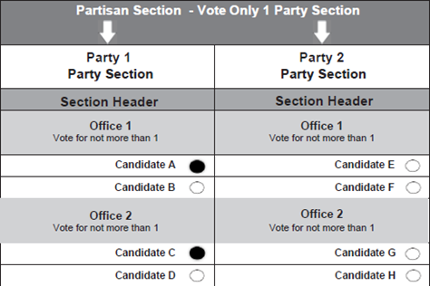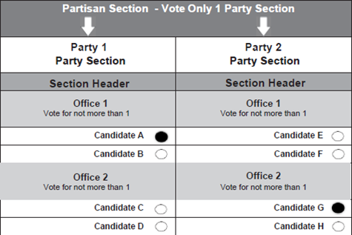

Example 3: Count a vote for party 4.
Example 4: Count a vote for candidate D.
Figure for 168.773 (1-2)
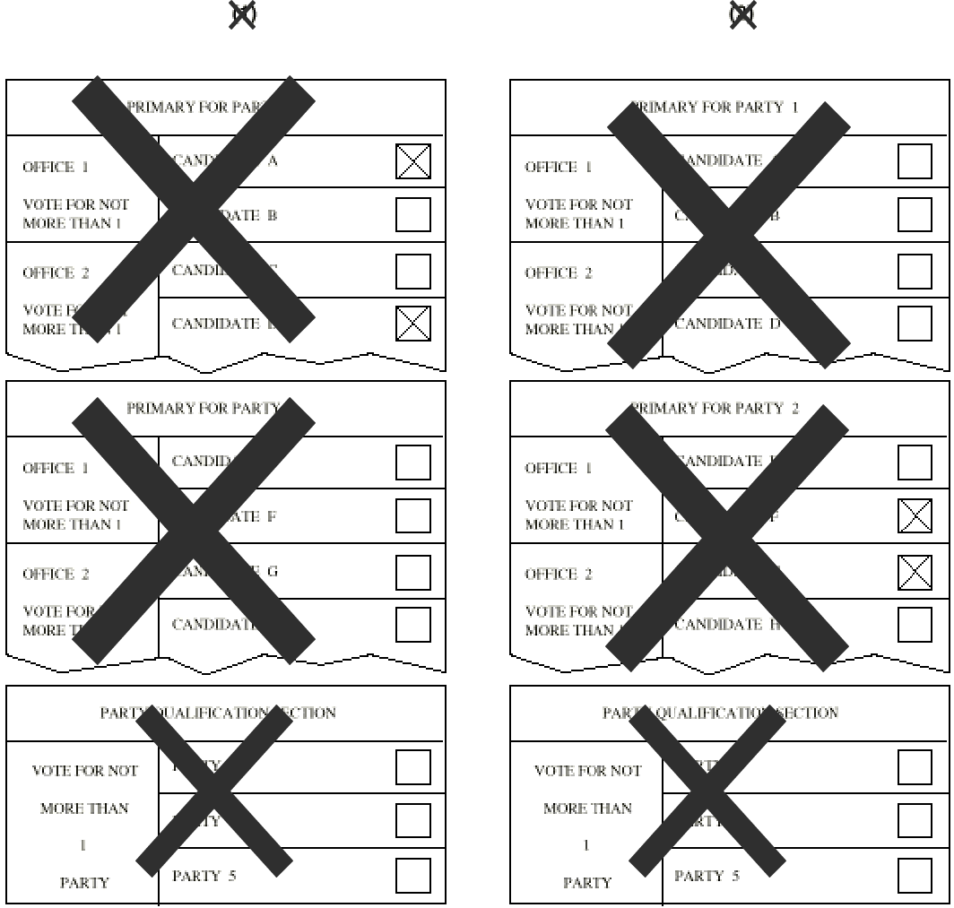

Figure for 168.773 (3-4)
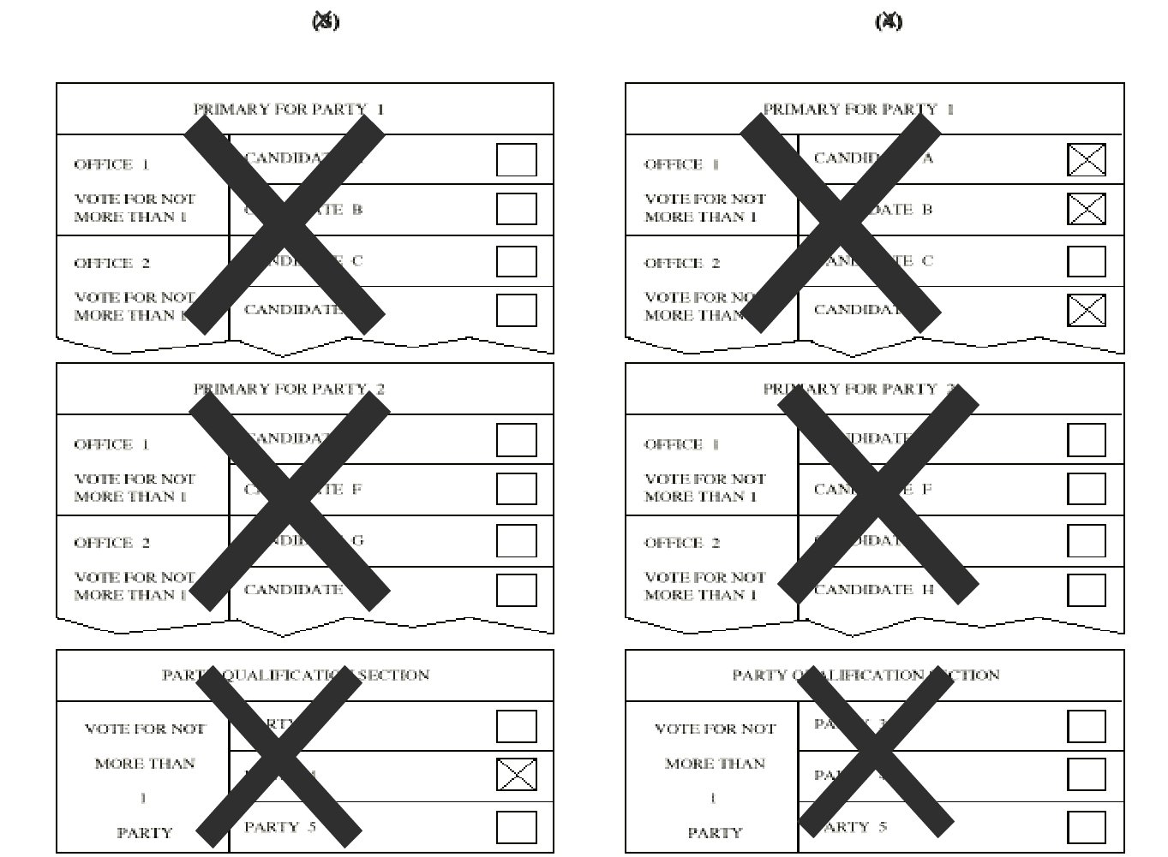

(d) To reject all votes cast in the partisan section of the ballot and the “party qualification section” of the ballot if votes are cast for candidates of more than 1 political party; or if votes are cast for candidates of 1 or more political parties and 1 or more votes are cast in the “party qualification section” of the ballot; or if more than 1 vote is cast in the “party qualification section” of the ballot, as in examples 5, 6, 7, 8, and 9.

Example 5: Count no votes.
Example 6: Count no votes.
Example 7: Count no votes.
Example 8: Count no votes.
Example 9. Count no votes.
Figure for 168.773 (5-7)
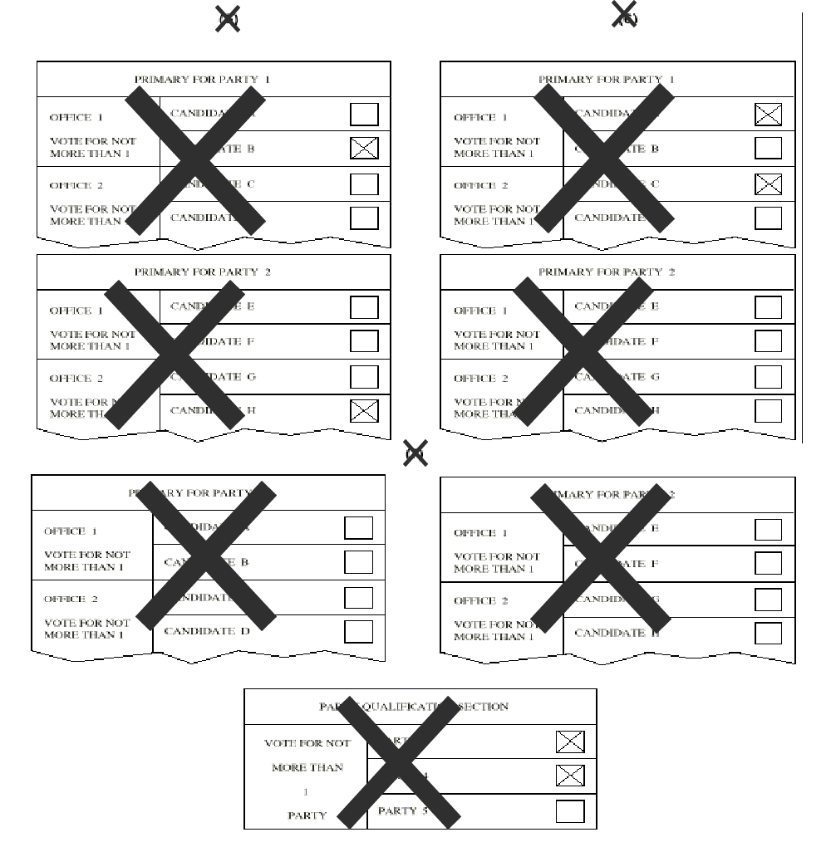

Figure for 168.773 (8-9)
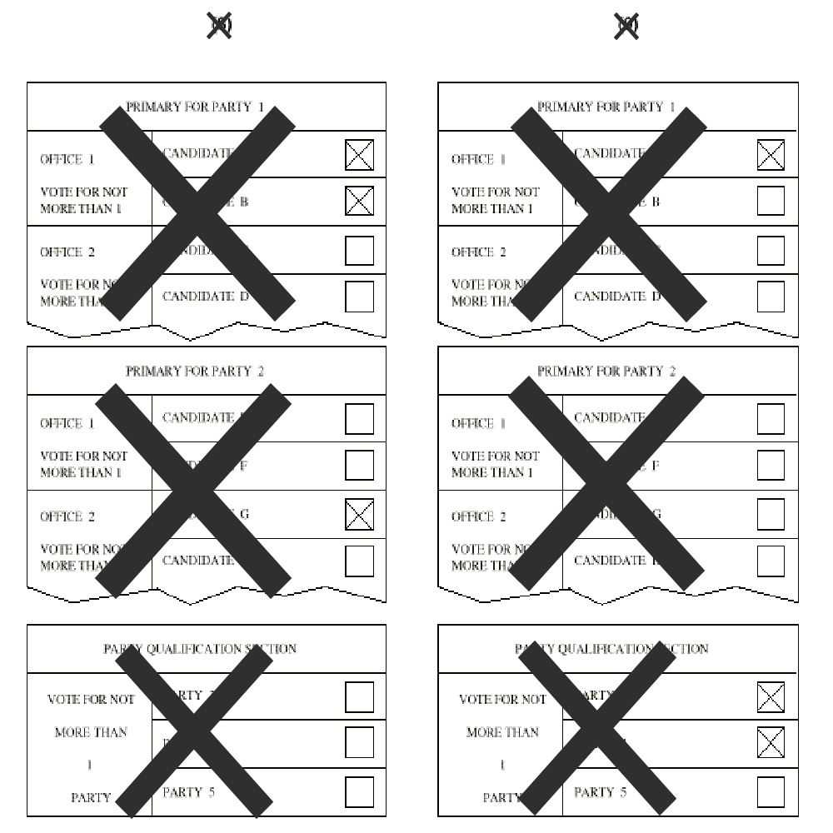

(126) In addition to applicable requirements under subrule (4) of this rule, F for a partisan general election, the vote tabulation section of the program shall must be written as follows:
(a) A vote must shall be counted for each candidate of the political party indicated by the voter’s straight ticket vote, if any other another vote does not appear on the partisan portion of the ballot, as in example 103.

Figure for 168.773 (10-11)
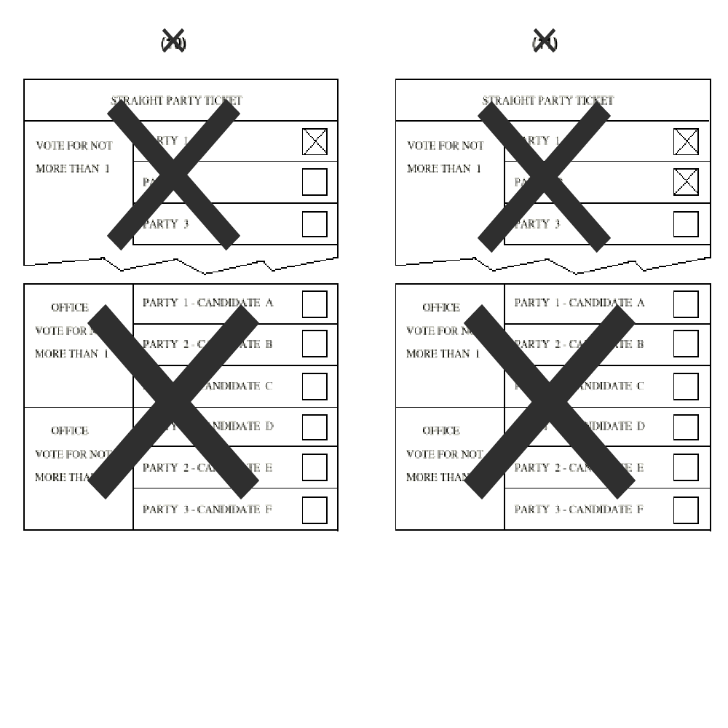Example 10: Count a vote for candidates A and D.
(b) A vote shall not be counted if the voter has voted more than 1 straight ticket vote and another vote does not appear on the partisan section of the ballot, as in example 11 A vote must not be counted if the voter has voted more than 1 straight ticket vote and another vote does not appear on the partisan section of the ballot, as in example 4.

Example 3: Count a vote for candidates B and G.

Example 4: Do not count a vote for candidates of any party.

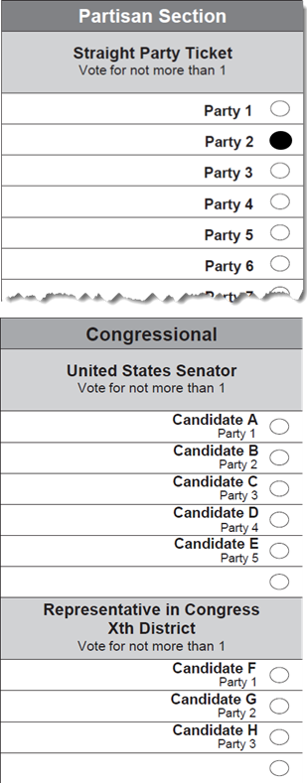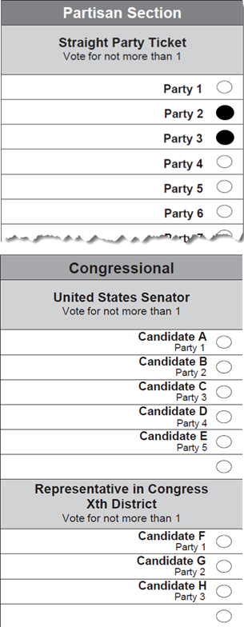
Example 3: Example 4:

Example 11: Do not count a vote for candidates of any party.

(c) When only 1 candidate is to be elected to an office and the voter has voted a straight party ticket and voted for individual candidates, a vote shall must be counted for each of the individual candidates voted for, and for each candidate of the party for which the straight party vote was voted and individual votes for candidates of other parties were not voted, as in examples 12 5 and 13 6.

Example 125: Count a vote for candidates B and EG.

Example 136: Count a vote for candidates B and D F.

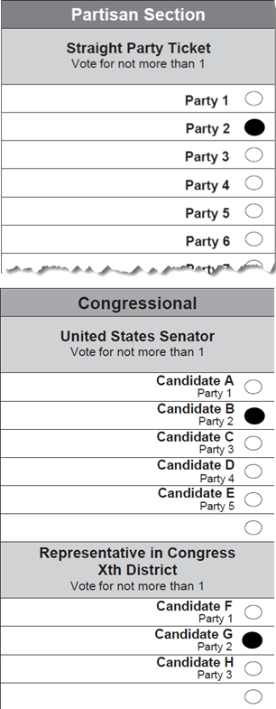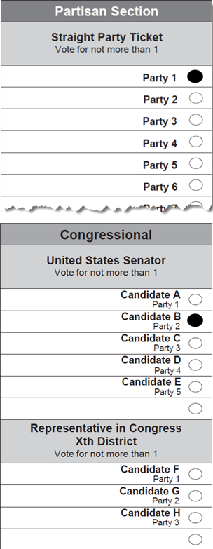
Example 5: Example 6:

Figure for 168.773 (12-13)

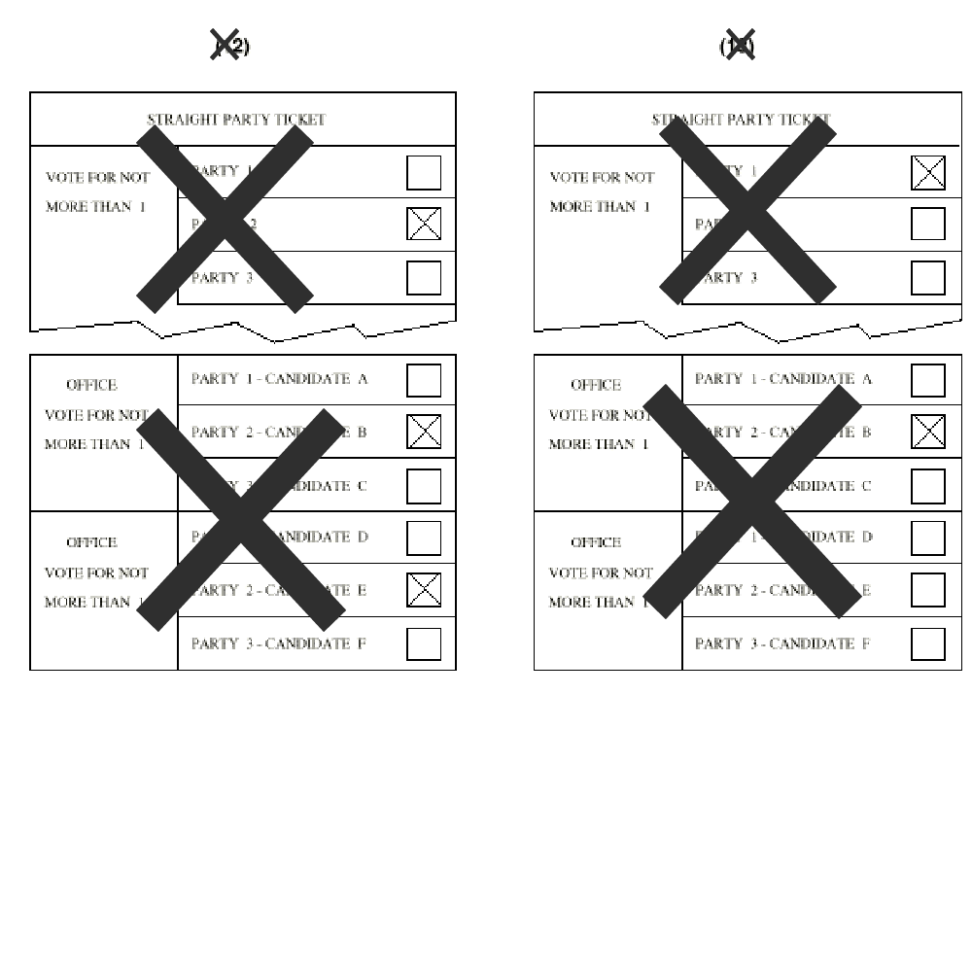
(d) When 1 or more candidates are to be elected to an office and the voter has voted 2 or more straight party tickets and the individual votes for partisan candidates, a vote shall must be counted for each individual candidate voted for when the number of votes for that office does not exceed the number for which the voter is entitled to vote, as in examples 147, 158, and 169.
Example 147: Count a vote for candidates A and D G.

Example 158: Do not count a vote for candidates of any party.

Example 169: Count a vote for candidate F H.
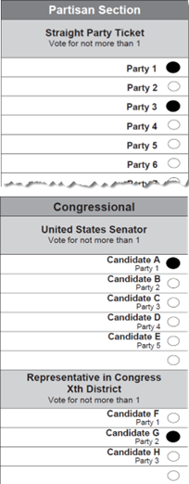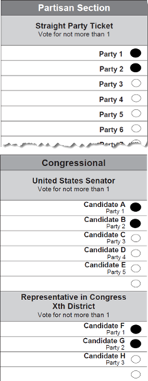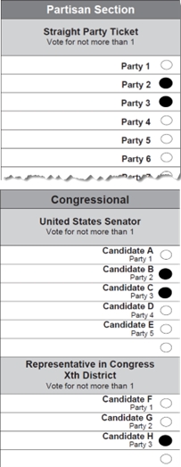
Example 7: Example 8: Example 9:

Figure for 168.773 (14-16)

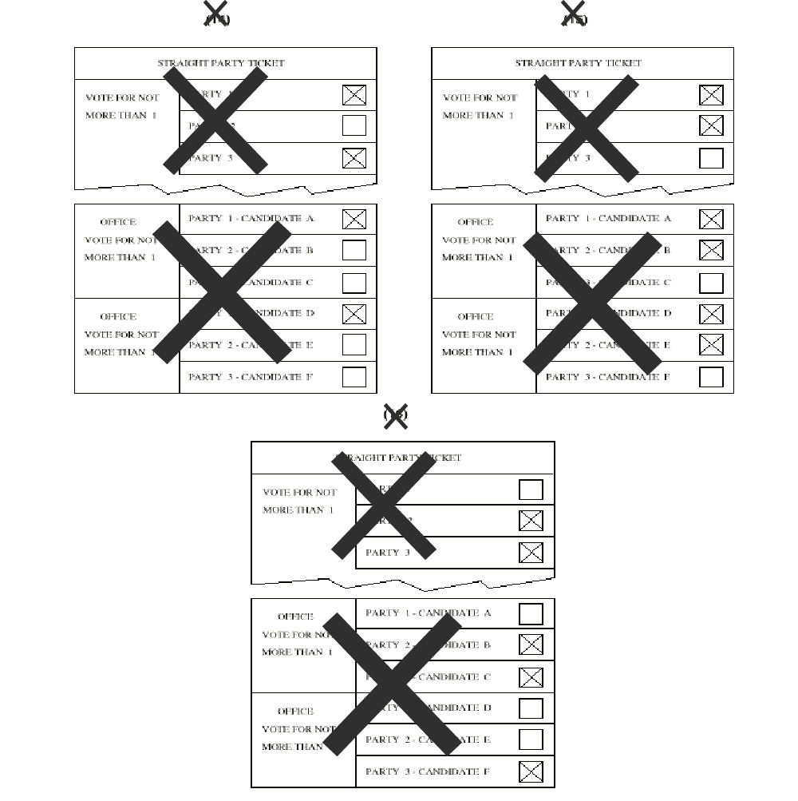
(e) When 2 partisan candidates are to be elected to the same office and the voter has voted a straight party ticket for 1 political party and has voted individually for 2 candidates of a different political party for that office, a vote must shall be counted for each of the candidates for whom the individual votes were voted, but votes must shall not be counted for the candidates of the party indicated by the voter’s straight party selection for that office, as in examples 1710, 1711, and 1912.

Example 1710: Count a vote for candidates A, B, H, and I.

Example 1711: Count a vote for candidates D, E, F, and G.

Example 1912: Count a vote for candidates C, D, I, and J.

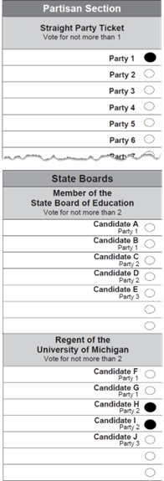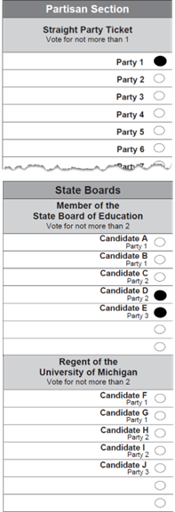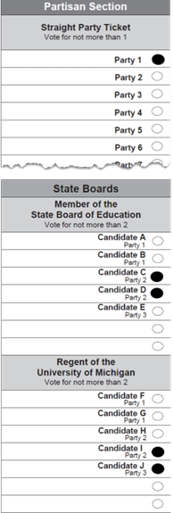
Example 10: Example 11: Example 12:

Figure for 168.773 (17-18)
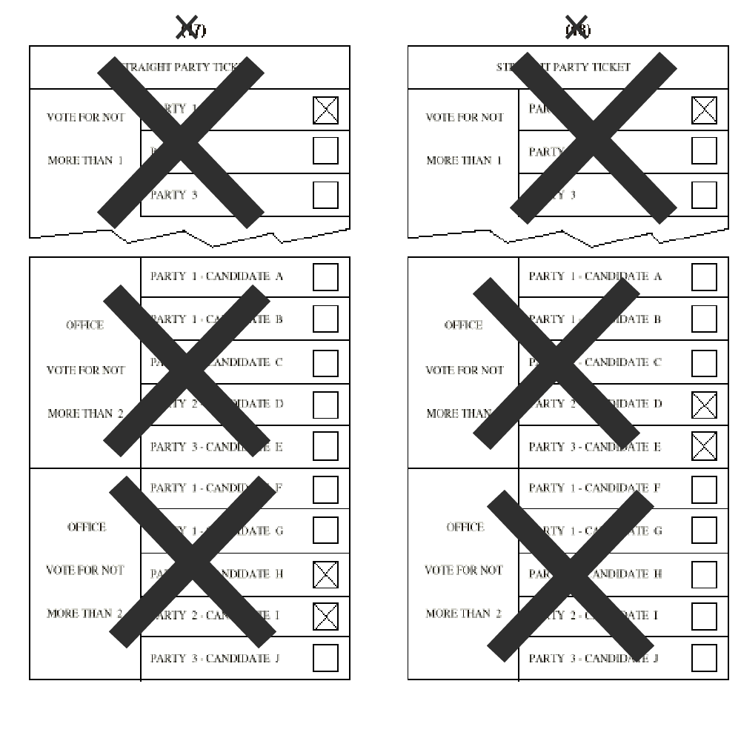
Figure for 168.773 (19)
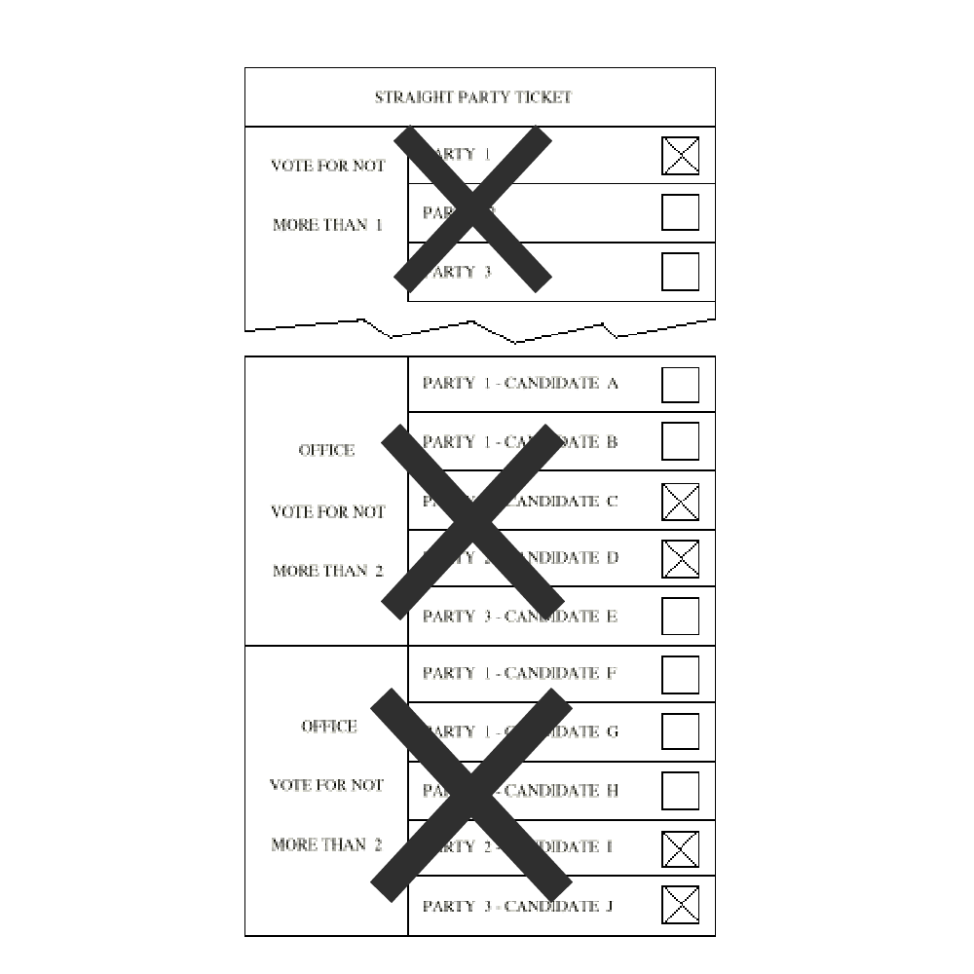
(f) When 2 partisan candidates are to be elected to the same office and the voter has voted a straight party ticket for 1 political party and that party has 2 candidates for that office, and the voter has voted an individual vote for 1 candidate for that office in a different political party, a vote must shall be counted only for the candidate for whom the individual vote was made. Under these conditions, a vote must shall not be counted for a candidate for that office by virtue of the voter’s straight party selection, as in examples 2013, 2114, 2215, and 2316.

Example 2013: Count a vote for candidate C only.

Example 2114: Count a vote for candidates A and B.

Example 2215: Count a vote for candidates B and C.

Example 2316: Count a vote for candidate E only.

Example 13: Example 14:
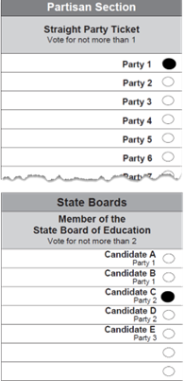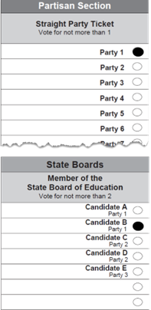
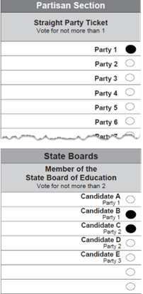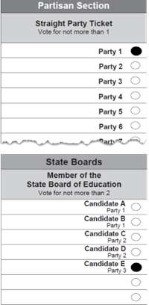
Example 15: Example 16:

Figure for 168.773 (20-23)
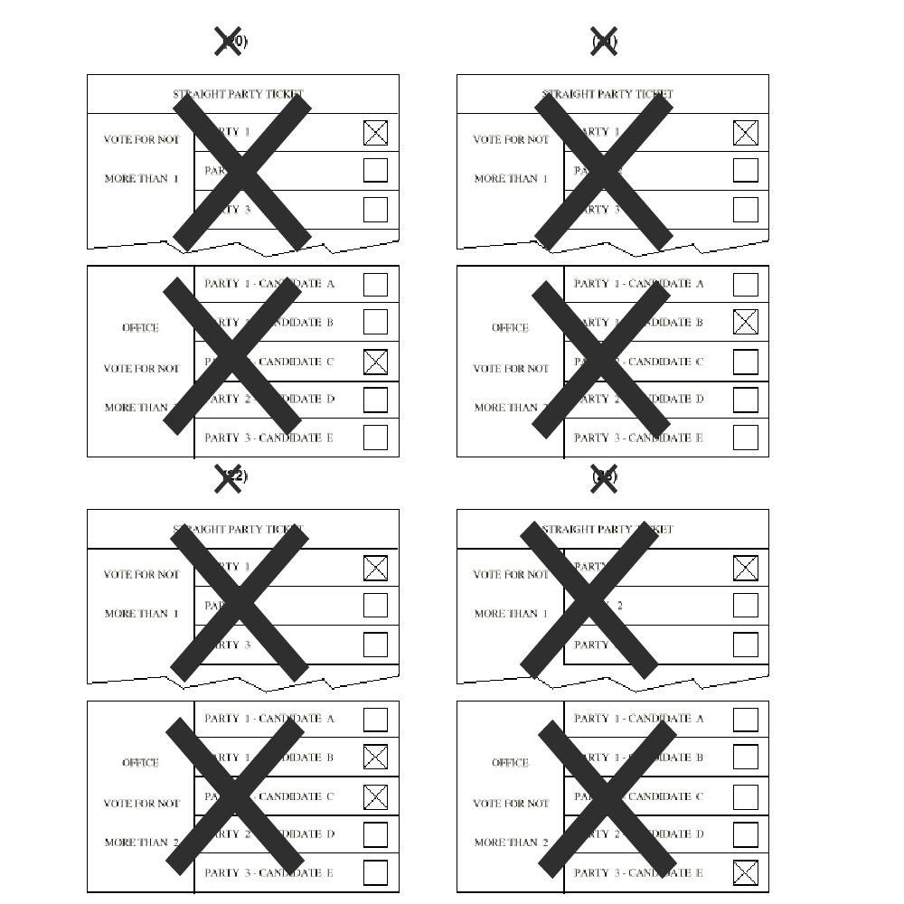

(g) When 2 partisan candidates are to be elected to the same office and the voter has voted a straight party ticket for 1 political party and that party has only 1 candidate for that office, a vote must shall be counted for the party candidate for that office as in example 2417, and if the voter has voted for a candidate of a different political party for that office, that vote must shall be counted, as in example 2518.

Example 2417: Count a vote for candidate E.

Example 2518: Count a vote for candidates B and E.
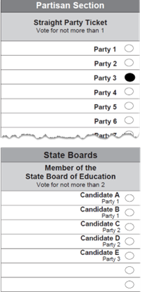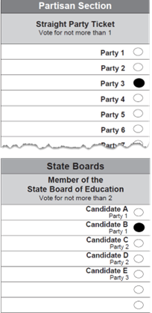
Example 17: Example 18:

Figure for 168.773 (24-25)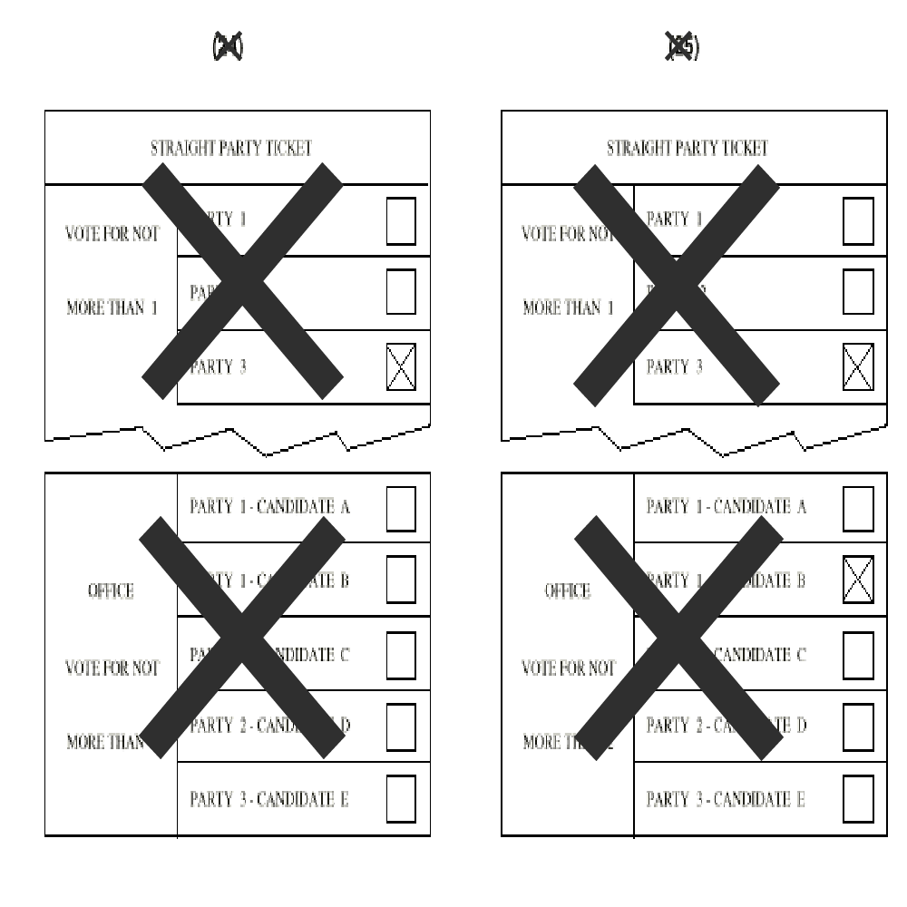
(h) When a voter has voted a straight party ticket for a political party and has voted individual votes for members of that party only, a vote must shall be counted for each candidate of that party. These conditions do not constitute an overvote, as in example 2619.

Example 2619: Count a vote for B C and E D.

Example 19:
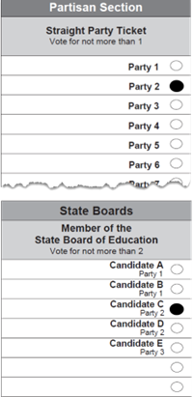

Figure for 168.773 (26)
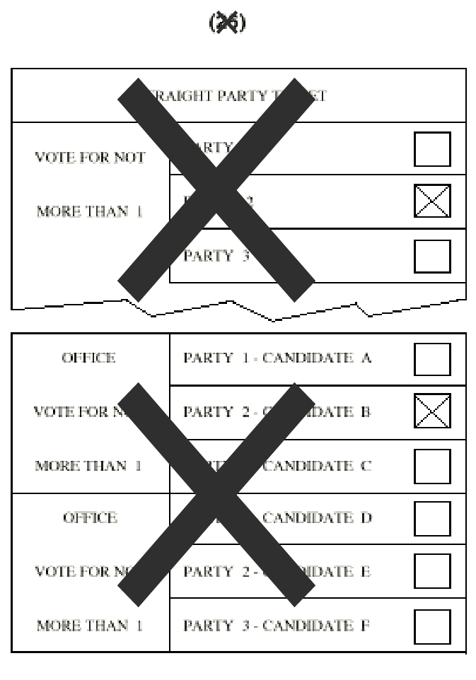

R 168.774 Preparation of ballots and ballot labels.
Rule 4. (1) On a ballot card used after the effective date of these rules, the words “OFFICIAL BALLOT CARD” must shall be printed on the face of the detachable stub ballot. The ballot card shall have a corner cut on 1 corner.
(2) If the ballot is printed on both sides, Tthe following statement, or a substantially similar statement, must shall be printed or stamped on the back of the stub on official ballot cards both sides of the ballot in boldface capital letters: “VOTE BOTH FRONT AND BACK OF THE BALLOT.”

STOP
WRONG SIDE
TURN CARD OVER

(3) The precinct or absent voter counting board number must shall be printed or, stamped, written, or punched on each ballot card used in an election to designate the precinct or county board from which it originated.
(4) A combination ballot card and write-in ballot to be used in an election shall be approved by the board of state canvassers.
(54) A ballot envelope secrecy sleeve to be used in an election shall be approved by the board of state canvassers and shall must satisfy all of the following requirements:
(a) Be made of paper of a sufficient size, weight, and design to preserve the secrecy of the ballot card.
(b) Have an inner pocket into which the ballot card may be inserted.
(c) Display printed instructions as to the method of inserting the ballot card after voting., and if the ballot envelope is to be used for write-ins, shall display instructions and space for casting a write-in vote.
(65) Except when ballots will be produced by an on-demand ballot printing system, T the number of ballots cards and envelopes required to be printed and distributed to each precinct must satisfy the following shall:
(a) For the general election, be not less than a number equal to the number of registered voters as of the close of registration plus 25%.
(b) For a primary election, be not less than a number equal to the total number of votes cast in the most recent corresponding primary election plus 25%.
(c) For a special or local election, be a number determined by the local clerk.
(6) When ballots will be produced by an on-demand ballot printing system during early voting, the total number of ballots printed from an on-demand ballot printing system in the previous corresponding election where early voting was used may count towards the total number of ballots to be printed. The number of ballots required to be printed and distributed to each election day precinct must satisfy the following:
(a) For the general election, be not less than 100% of the number of registered voters.
(b) For a primary election, be not less than the number of votes cast in the most recent primary election plus 25%.
(c) For a special or local election, be a number determined by the local clerk.
(7) A question, proposal, or proposition shall be placed last on the ballot label following the names of candidates and shall be placed in the following order: state, county, local. An exemption from this requirement may be obtained prior to the election from the secretary of state in writing.
(87) For a general election, the name of the party that which a candidate represents must shall be printed along with the name of the candidate.
(98) The names of candidates on the ballot labels shall must be rotated as follows:
(a) For a primary election, the names under each office shall must be rotated when there are more names than there are candidates to be nominated for office.
(b) For a general election, the names of partisan candidates under the title of each office shall must not be rotated.
(c) In any an election, the names of nonpartisan candidates must shall be rotated when there are more names than there are candidates to be elected for the office.
(d) Rotation must shall be by precinct in the manner provided by law for voting machines.
(e) Rotation shall be throughout the local unit of government preparing the labels.
(fe) When absent voter ballots are to be processed in the precinct, the rotation must shall be the same as in that precinct.
(g) When absent voter ballot cards are to be processed by an absent voter counting board, the rotation may be either by precinct using each absent voter counting board as a separate precinct, or by individual ballot in the same manner as paper ballots. In the latter instance, the punch number assigned to a candidate which corresponds to the respective position number on the ballot card shall be rotated with the candidate’s name.
(109) Voting instructions shall be printed on the first page of the ballot label. The ballot label shall contain instructions as to where the voter is to continue voting. Additional instructions which conform with the act may be printed on the ballot label The procedures for ballots produced by an on-demand ballot printing system must comply with section 720c of the act, MCL 168.720c.
(11) Absent voter instruction ballots which are used in conjunction with a ballot card shall be printed in plain, clear type and contain instructions for voting. There shall be printed in boldface type alongside each candidate’s name and the choice for each measure, a number which corresponds to the respective position number on the ballot card. The words “ABSENT VOTER INSTRUCTION BALLOT” shall appear at the head of the absent voter instruction ballot. An absent voter instruction ballot may be a facsimile of the ballot label used in the absent voter’s precinct. Arrows placed on the ballot labels may be omitted from the absent voter instruction ballot.
(12) When a state office or question appears on the ballot, the county election commission shall forward to the secretary of state for approval 2 copies of an instruction ballot or ballot label, 2 copies of an absent voter instruction ballot including all instructions forwarded to absent voters, 2 copies of a ballot card, and 2 copies of a ballot envelope.

R 168.775 Preparation of voting device tabulators.
Rule 5. (1) The clerk or an authorized assistant shall prepare each voting device tabulator pursuant to the provisions of the act and these rules.
(2) A voting device tabulator must shall be identified labeled with the precinct number in which it shall is to be used if more than 1 tabulator is in the polling place, early voting site, or absent voter ballot counting facility.
(3) A ballot label page used in the voting device shall be firmly attached for insertion and positioning in the ballot frame. A person shall not attach a ballot label by tape to a rod, or place a ballot label into a clear plastic envelope through which a rod is inserted A tabulator must be programmed to notify the voter if the voter submits a blank ballot, a ballot containing overvotes, or a partisan primary ballot that is invalid due to crossover voting, as tested by the preliminary test and public logic and accuracy test. The tabulator must provide the voter with the following options:
(a) The voter may acknowledge that no vote will be awarded if a ballot is blank or in a contest that contains an overvote or crossover vote and submit the ballot to the tabulator.
(b) The voter may remove the ballot from the tabulator, spoil the ballot, and receive a replacement ballot from the election inspectors. If the ballot is blank, the voter may remove the ballot from the tabulator, vote the ballot, and resubmit the ballot to the tabulator.
(4) The ballot label assembly shall be inserted and sealed into each voting device so that the ballot label assembly cannot be removed without breaking the seal. Seals approved by the board of state canvassers shall be used for this purpose.
(5) The ballot label of each voting device of a precinct shall be compared against the edit listing and instruction ballot for the precinct to ascertain that the offices, candidates’ names, and ballot position numbers are the same and appear in the same position.
(6) The ballot labels of each device shall be examined to ascertain that holes in the mask appear directly opposite each arrow, that other holes do not appear in the mask, and that the ballot labels are in proper sequence.
(74) An assembled voting device tabulator must shall be tested to determine if it is operating properly, as described in these rules.
(5) A tabulator must be sealed at all times the tabulator is being used for voting or is being stored.
(86) The identifying number of the voting device tabulator and the seal number used to seal the ballot label assembly to the device tabulator must shall be recorded on the certificate in the poll book physical pollbook for the precinct in which the device tabulator is to be used. The clerk or an authorized assistant who sealed the device tabulator shall sign the certificate.
(97) When a voting device tabulator has been prepared for the election, the election commission, the clerk, or an authorized assistant shall execute a certificate in writing, which shall must be filed with the election commission of the jurisdiction in which they are authorized to act. The certificate must shall contain the precinct number, the identifying number of the device tabulator, and the number of the seal or seals used to seal the device, and state that the ballot labels have been compared against the edit list for that precinct and that the candidates’ names and ballot numbers agree and appear in the same position and state that the device tabulator has been properly prepared and tested. If the certificate is signed by an individual other than the election commission, the election commission or its authorized assistant shall be offered an opportunity to inspect the voting device tabulators to determine whether they are properly prepared. In an election when state and county officers or measures are to be voted for, a duplicate certificate must shall be filed with the county clerk.

R 168.775a Preparation of accessible voting device.
Rule 5a. (1) The clerk or an authorized assistant shall prepare each accessible voting device pursuant to the provisions of the act and these rules.
(2) An accessible voting device must be tested to determine if it is operating properly, as described in these rules.
(3) An accessible voting device must be sealed at all times the device is being used for voting or is being stored.
(4) The identifying number of the accessible voting device and the seal number used to seal the device must be recorded on the certificate in the physical pollbook for the precinct in which the device is to be used. The clerk or an authorized assistant who sealed the device shall sign the certificate.
(5) When an accessible voting device has been prepared for the election, the election commission, the clerk, or an authorized assistant shall execute a certificate in writing, which must be filed with the election commission of the jurisdiction in which they are authorized to act. The certificate must contain the following information:
(a) The precinct number or numbers.
(b) The identifying number of the device.
(c) The number of the seal or seals used to seal the device.
(d) A statement that the device has been properly prepared and tested.
(6) If the certificate is signed by an individual other than the election commission, the election commission or its authorized assistant shall be offered an opportunity to inspect the accessible voting devices to determine whether they are properly prepared.
(7) In an election when state and county officers or measures are to be voted for, a duplicate certificate must be filed with the county clerk.
(8) Before the opening of polls on each day the accessible voting device is used in an election, a test ballot, marked “test,” must be loaded into the device and a blank ballot must be printed. The test ballot must not be tabulated and must be returned to the local clerk at the end of the day.

R 168.776 Preparation of official test deck.
Rule 6. (1) The election commission providing the program responsible for the election or its authorized assistant shall prepare a test deck for each precinct and ballot style with predetermined results.
(2) The test deck must shall consist of ballots cards of the same type to be used in the election with the word “TEST” stamped, printed, or written on each card ballot.
(3) A document, record, chart, or listing must shall be prepared indicating the punches selections recorded in the test ballot card. This documentation must shall indicate each valid or invalid vote.
(4) In addition to other requirements of the act, a ballot card for use in the test deck for a partisan general election must shall be prepared as follows:
(a) So that each political party receives not less than 2 straight ticket votes and so that any 2 parties do not receive the same number of straight ticket votes.
(b) So that 2 or more parties receive straight ticket votes on 1 ballot.
(c) So that at least 1 of the ballots with a straight ticket vote for a party must shall be individual punches selections for candidates of the same party, candidates of a different party, candidates for the same office of different parties, and nonpartisan candidates and proposals.
(d) In which punches selections appear in positions other than those used for candidates, proposals, or to indicate straight party voting.
(e) In which a punch selection does not appear.
(f) In which a punch selection appears in each position where a candidate or proposal appears on the ballot label.
(5) In addition to other requirements of the act, a ballot card for use in the test deck for a partisan primary must shall be prepared as follows:
(a) So that punches selections appear on the same ballot card for candidates of different political parties, along with candidates for nonpartisan offices and votes for proposals.
(b) So that punches selections appear on the same ballot card for candidates of 1 or more political party and a punch made in the “party qualification section” of the ballot, and must shall include punches selections for nonpartisan offices and for proposals.
(c) So that more than 1 punch appears in the “party qualification section” of the ballot.
(6) When 2 or more valid punch positions exist in the combination of numbers listed below, each of the valid punch positions shall be punched into 1 or more ballot cards:

228 Position Ballot Card

1-77-153 20-96-172 39-115-191 58-134-210
2-78-154 21-97-173 40-116-192 59-135-211
3-79-155 22-98-174 41-117-193 60-136-212
4-80-156 23-99-175 42-118-194 61-137-213
5-81-157 24-100-176 43-119-195 62-138-214
6-82-158 25-101-177 44-120-196 63-139-215
7-83-159 26-102-178 45-121-197 64-140-216
8-84-160 27-103-179 46-122-198 65-141-217
9-85-161 28-104-180 47-123-199 66-142-218
10-86-162 29-105-181 48-124-200 67-143-219
11-87-163 30-106-182 49-125-201 68-144-220
12-88-164 31-107-183 50-126-202 69-145-221
13-89-165 32-108-184 51-127-203 70-146-222
14-90-166 33-109-185 52-128-204 71-147-223
15-91-167 34-110-186 53-129-205 72-148-224
16-92-168 35-111-187 54-130-206 73-149-225
17-93-169 36-112-188 55-131-207 74-150-226
18-94-170 37-113-189 56-132-208 75-151-227
19-95-171 38-114-190 57-133-209 76-152-228

235 Position Ballot Card

21-78 40-117 1-97-136-156-176-196-216 22-79
41-118 2-98-137-157-177-197-217 23-80 42-119
3-99-138-158-178-198-218 24-81 43-120
4-100-139-159-179-199-219 25-82 44-121
5-101-140-160-180-200-220 26-83 45-122
6-102-141-161-181-201-221 27-84 46-123
7-103-142-162-182-202-222 28-85 47-124
8-104-143-163-183-203-223 29-86 48-125
9-105-144-164-184-204-224 30-87 49-126
10-106-145-165-185-205-225 31-88 50-127
11-107-146-166-186-206-226 32-89 51-128
12-108-147-167-187-207-227 33-90 52-129
13-109-148-168-188-208-228 34-91 53-130
14-110-149-169-189-209-229 35-92 54-131
15-111-150-170-190-210-230 36-93 55-132
16-112-151-171-191-211-231 37-94 56-133
17-113-152-172-192-212-232 38-95 57-134
18-114-153-173-193-213-233 39-96 58-135
19-115-154-174-194-214-234
20-116-155-175-195-215-235
(7) A duplicate of the test deck shall be prepared. The duplicate of the test deck may consist of standard data processing cards.

R 168.777 Preliminary accuracy test.
Rule 7. (1) The election commission providing the program responsible for the election or its the commission’s authorized assistant shall conduct a preliminary accuracy test of the computers and programs tabulators and accessible voting devices for all precincts as early as practicable, but before prior to the public accuracy test.
(2) The preliminary accuracy test must shall be conducted using the test decks prepared under the direction of the commission. For the purpose of this test, the test deck may be reproduced onto standard data processing cards.
(3) When an errorless count has been made for all precincts, the commission responsible for the election or its authorized assistant providing the program shall do all of the following:
(a) If practicable, perform end-to-end testing to ensure the program accurately transmits the totals to the electronic management system.
(ab) Secure the programs, test decks, and predetermined results in an approved ballot metal container, which must shall be sealed with an metal approved seal.
(bc) Certify that all precincts have been tested using the test deck prepared under the direction of the commission and that the results agree with the predetermined results of the test deck. The certificate must shall contain the number of the seal that which was used to secure the program.
(cd) Deliver programs, test decks, predetermined results, and the certificate to the clerk of the unit of government providing the program responsible for the election.

R 168.778 Public A accuracy test.
Rule 8. (1) If early voting is being offered for the jurisdiction, Tthe election commission providing the program responsible for early voting shall designate a time and place for an public accuracy test, which must shall be held not less than 5 days before the election start of early voting in accordance with the requirements of section 798 of the act, MCL 168.798.
(2) If no early voting is being offered for the jurisdiction, the election commission responsible for the election shall designate a time and place for a public accuracy test, which must be held not less than 5 days before the election.
(23) The public accuracy test must shall be conducted by an accuracy board, which shall be the election commission supplying the program responsible for the election. A member of the commission may designate an person individual to serve in his or her the member's place on the accuracy board. A member of the commission who designates an person individual to serve at the public accuracy test shall notify the clerk before the test. The clerk of the commission or the designated representative of the clerk shall be is the chairperson.
(3) Members of the accuracy board shall be present at the accuracy test.
(4) The clerk in charge of the program responsible for the election may limit the number of persons individuals who may be in the computer room and the duration of their stay in the computer room present for the public accuracy test based on room capacity.
(5) The initial testing of the computers tabulators and programs must shall be with the official test deck prepared under the direction of the commission. The number of precincts to be tested must shall be determined by the accuracy board commission. The members of the accuracy board commission may prepare or cause to have prepared additional ballots cards to be included in the official test deck.
(6) Each program and test deck shall must be tested on the computer tabulator on which it is to be used for the election.
(7) After demonstrating the accuracy of the programs and computers, the following persons may prepare test ballot cards for testing:
(a) A member of a board of canvassers which shall certify all or part of the election or a designated representative.
(b) The county chairperson of each political party appearing on the ballot or a designated representative.
(c) A candidate whose name appears on the ballot or a designated representative.
(d) A representative from each group interested in a proposal or measure who has informed the commission in writing of that person’s intent to participate in the testing procedure. The number of cards each eligible person is allowed to prepare shall be determined by the accuracy board, except that an eligible person shall not be limited to less than 10 cards The election commission shall test the accessible voting devices as prescribed by the secretary of state as part of the public accuracy test.
(8) The election commission shall test the on-demand ballot printing system as prescribed by the secretary of state as part of the public accuracy test.
(89) The commission supplying the program shall provide the following items at the accuracy test:
(a) An edit listing.
(ba) Test ballots cards.
(cb) At least 1 set of ballot labels or sample ballots for each precinct.
(c) The chart of predetermined results.
(910) If an error is detected in the testing, the cause must shall be ascertained, the error must shall be corrected, and an errorless count must shall be made for all precincts. If determined by the accuracy board commission, the meeting may be adjourned to a time and date certain.
(101) The secretary of state or a designated representative may provide a test deck for a program. If so, it must shall be delivered at the public accuracy test. At the discretion of the secretary of state, it may be used in place of, or in addition to, the test deck prepared by the commission.
(112) The accuracy board commission shall certify the accuracy of the test. The certification may be attached to, or written on, the computer printed results of the public accuracy test.
(123) The accuracy board commission shall secure all programs, test decks, certified computer results of the test, and the predetermined results in an approved metal container, which must shall be sealed with an approved metal seal in a manner so that the container cannot be opened without breaking the seal. There must Attached to or inside the container shall be a certificate describing its contents and on which with the number of the seal has been recorded attached to or inside the container. The certificate must shall be signed by the members of the accuracy board commission, and, if attached to the container in a plastic envelope, it must shall be attached in such a manner that it cannot be removed without breaking the seal.
(134) The accuracy board commission shall immediately deliver to the clerk in charge of the election the metal case approved ballot container containing the programs and test decks. The clerk shall retain and secure the programs.

R 168.779 Preparation and delivery of election supplies materials.
Rule 9. (1) The clerk of the unit of government providing the voting devices tabulators or an authorized assistant shall place into an transfer case approved ballot container the ballots cards for each precinct or early voting site. The transfer case approved ballot container shall must be secured with an metal approved seal and contain a certificate signed by the clerk or an authorized assistant setting forth the number of ballots in the case container and that the ballots were counted and sealed in the approved ballot container by the clerk or by an authorized assistant. Ballots cards not issued to a precinct or early voting site or assigned for absentee voting must shall be secured and accounted for by the clerk. The clerk shall maintain a record of the number of ballots cards and serial numbers issued to each precinct or early voting site. The ballots cards shall must be delivered to the chairperson or a member of the board of election inspectors of the proper precinct or early voting site.
(2) Precinct supplies and early voting site supplies must shall include the following items:
(a) An edit listing for the precinct.
(ba) A pencil for each voting device A sufficient number of black or blue ink marking devices for voters to mark ballots.
(cb) A set of instructions for operating the precinct on election day or operating the early voting site during the early voting period.
(dc) An envelope labeled “SPOILED BALLOTCARDS”.
(ed) An envelope labeled “ORIGINAL BALLOTCARDS FOR WHICH DUPLICATES HAVE BEEN MADE FOR ANY REASON” if the duplication is to be done at the precinct.
(3) If the precinct header card is sent to the precinct, it shall be contained in an envelope for that purpose and included in the transfer case for the precinct.
(43) The voting devices, demonstration voting devices tabulators, accessible voting devices, on-demand ballot printing systems, voting booths, ballots cards, ballot envelopes secrecy sleeves, transfer case approved ballot containers, and all other necessary supplies must shall be delivered to the precinct not later than 6:30 a.m. on election day or no later than 30 minutes before the start of early voting at an early voting site.
(54) A ballot box Approved ballot containers must shall be provided to each precinct or early voting site for the deposit storage of voted ballots cards. The ballot box shall be capable of being locked or sealed during election day.

R 168.780 Clerks and E election inspectors; duties prior to before opening of polls.
Rule 10. (1) Voting devicesbe usedmust occur in voting booths or in self-contained voting stations.
(2) If voting devices are used in self-contained voting stations, t The stations voting booths must shall be arranged so that the secrecy of the ballot is not violated.
(3) Before the opening of polls, the clerk shall do all of the following:
(a) Ensure that election inspectors who need access to the electronic pollbook are able to access it.
(b) Ensure that tabulators and accessible voting devices are provided to each early voting site and election day polling place.
(c) Ensure that the serial numbers and seal numbers for tabulators, accessible voting devices, and on-demand ballot printing systems agree with the numbers in the physical pollbook.
(d) Ensure that all necessary election equipment and election materials are available at the early voting site and polling place.
(e) Ensure that all signage is correctly displayed.
(f) Establish an area for poll watchers.
(34) Before the opening of polls, T the election inspectors shall do all of the following:
(a) Compare the seal number and identifying numbers on the devices with the numbers recorded in the poll book Verify that the electronic pollbook and prescribed backup materials are available at the polling location.
(b) Compare the names, proposals, and ballot position numbers printed on the ballot labels, edit listing, and precinct instruction ballot to ascertain that the offices, proposals, and candidate names are the same and appear in the same order on each Verify that all election inspectors who need to access the electronic pollbook are able to access it.
(c) Verify that the ballot label pages are in the proper order Verify that the tabulator and accessible voting device are plugged in, powered on, and secured as required by these rules.
(d) Check the mask to see that holes only appear directly opposite each arrow and that the arrow points directly to the hole opposite it.
(e) Place a demonstration card into each device and make a punch for each candidate and proposal on the ballot. The inspector shall examine the card to see that each candidate and proposition received a proper punch.
(fd) Verify that there is a pencil black or blue ink marking device provided for in each device voting booth.
(g) Check each stylus to see that it is not broken.
(he) Determine that there is adequate lighting.
(45) In the event of a discrepancy that election equipment is unavailable or potentially unusable, the election inspectors shall notify the clerk immediately and the voting device shall not be used until the discrepancy is resolved.
(5) The demonstration voting device shall be placed so as to afford each voter an opportunity to use it prior to voting.

R 168.780a Early voting.
Rule 10a. (1) In addition to the duties before the opening of polls, as part of early voting responsibilities, the clerk or site supervisor shall do all of the following:
(a) On the first day of early voting before voting begins, all of the following:
(i) Ensure that the method of administering early voting in that municipality, whether as part of a county agreement, municipal agreement, or as a single municipality, is reflected in the programming of election equipment.
(ii) Print a summary zero report for each tabulator. Ensure the time and date are correct on the summary zero report.
(iii) Ensure that all election inspectors sign the bottom of the summary zero report and complete and sign the election inspectors’ certificate.
(iv) Attach the signed summary zero report and status report to the physical pollbook.
(b) On each subsequent day of early voting before voting begins, all of the following:
(i) Print a status report for each tabulator and accessible voting device.
(ii) Ensure that the number of ballots tabulated shown on the tabulator agrees with the number of votes tabulated on the previous day’s physical pollbook entry.
(iii) Print a blank test ballot on the accessible voting device. Label the blank test ballot “EARLY VOTING TEST BALLOT DAY [1, 2, 3, etc.]” and insert the ballot into the envelope for the local clerk.
(iv) If applicable, print a status report from the on-demand ballot printing system.
(c) At the end of each day’s early voting, secure all equipment as prescribed in section 720j of the act, MCL 168.720j.
(d) On election day following the close of polls, all of the following:
(i) Complete the final reconciliation and ballot summary page in the physical pollbook.
(ii) Tally the write-in votes as prescribed by the secretary of state.
(iii) Enter the tallies on the write-in statement of votes located in the physical pollbook.
(iv) Ensure all write-in ballots are returned to the approved ballot container.
(v) For each ballot container, complete a container certificate and seal with an approved seal. Enter the seal numbers on the final reconciliation and ballot summary page.
(vi) Close the polls for each tabulator according to vendor instruction, print 3 copies of the totals tape, ensure election inspectors sign the bottom of the tapes, and place 1 copy of totals tape in an envelope for the county clerk, 1 in an envelope for the county canvassers, and 1 in an envelope for the local clerk.
(2) In addition to the duties for election inspectors before opening of polls, as part of early voting responsibilities, the election inspectors shall do all of the following:
(a) On the first day of early voting before voting begins, all of the following:
(i) Have 2 election inspectors compare the summary zero report to a sample ballot to ensure that all races are included on the tape, the correct ballots were delivered to the precinct, and all totals equal zero on the summary zero report.
(ii) Have all inspectors sign the bottom of the summary zero report and complete and sign the election inspectors’ preparation certificate.
(iii) Attach the signed summary zero report and status report to the physical pollbook.
(iv) Before the opening of polls, record the number on the tabulator’s public counter in the physical pollbook.
(b) On each subsequent day of early voting before voting begins, all of the following:
(i) Enter the number on the tabulator public counter and the number of voters on the list of voters printed from the early voting electronic pollbook the previous day in the place specified on the election inspectors’ preparation certificate.
(ii) Verify that the number on the tabulator public counter is equal to the previous day’s daily reconciliation and ballot summary. If the numbers do not match, review the remarks page of the physical pollbook for notes and verify counts against the count of applications to vote.
(iii) Have all inspectors complete and sign the election inspectors’ preparation certificate.
(c) After the close of early voting each day, all of the following:
(i) Verify that the number of ballots tabulated that day equals the number of voters identified in the early voting pollbook as having been issued ballots at the early voting site that day and those tabulating absent voter ballots. If the numbers do not match, note the reason for the difference on the remarks page in the physical pollbook.
(ii) Print a poll list from the early voting pollbook of the electors who voted at the early voting site that day and add it to the physical pollbook.
(iii) Remove the voted ballots from the tabulator bin and seal the ballots, along with spoiled ballots and the early voting electronic pollbook, in a ballot container in the same manner as ballots are sealed on election day.
(iv) Record on the ballot container certificate the seal number used to seal the ballot container.
(v) Record in the physical pollbook the seal number used to seal the ballot container.
(vi) Record in the physical pollbook the number on the tabulator’s public counter at the end of the day.
(vii) Ensure the election materials are secured as instructed by the clerk or site supervisor.
(viii) Ensure the room in which the early voting site is located is locked.
(d) On election day following the close of polls, all of the following:
(i) Generate the summary totals tape from the early voting tabulators and make results available to those present.
(ii) Complete the statement of results, the ballot summary, and the certificate of election inspectors.

R 168.781 Conduct of election and manner of voting.
Rule 11. (1) The election inspector having charge of the ballots shall deliver to the voter an official ballot card and envelope secrecy sleeve. The ballot card stub number associated with the ballot, if there is a numbered stub, must shall be entered onto the application to vote at the time the card ballot is issued. The name of the voter and ballot card number issued shall then be entered into the poll book and the voter number must be entered on upon the application to vote.
(2) Upon being issued a ballot card and envelope secrecy sleeve, the voter shall enter a voting station booth and record his or her the voter’s selections on the ballot card. Before leaving the booth, the voter shall insert the ballot card in the ballot envelope secrecy sleeve with the detachable numbered stub, if there is a numbered stub, on the outside and so that any part of the face of the voting portion of the ballot card is not exposed.
(3) The election inspector designated to receive the ballot from the voter shall ascertain by comparing the number on the ballot card stub, if applicable, with the number recorded on the poll list application to vote whether the ballot given to the inspector is the same ballot furnished to the voter. If it is the same ballot, the inspector shall remove the detachable stub, if there is a numbered stub, and in the presence of the voter shall, deposit the ballot into the ballot box tabulator. If the ballot received is not the same ballot furnished to the voter, the ballot shall not be counted and the voter shall not be permitted to vote at the election the voter may be given a new ballot to vote, or the voter may decline to vote a new ballot, but in neither event may the non-matching ballot be counted. The non-matching ballot must shall be marked void with the reason therefor and inserted in an envelope and placed in the transfer case ballot container. In any event, t The non-matching ballot shall not be deposited with the valid voted ballots.
(4) If a voter is challenged, the election inspector shall do all of the following:
(a) Record the ballot number appearing on the stub, if there is a numbered stub, onto the back of the ballot envelope. If there is no numbered stub, record the voter number on the ballot.
(b) Cover the number with a slip of paper so as to conceal the number.
(c) Issue a the ballot to the challenged voter who will vote and cast the ballot in the usual manner. If a combination ballot card and write-in ballot is used, the ballot number shall be recorded on the back of the write-in portion of the ballot and covered in the same manner as described in this rule.
(5) It shall not be necessary to identify the ballot of an assisted voter in the same manner as that of a challenged voter.
(6) The election inspectors shall frequently check the seals and ballot label pages of the voting devices to ensure that none have been altered or defaced. If the board finds that the ballot pages of a device have been altered, mutilated, or damaged in such a manner that the board cannot correct them without doing damage to the offices, names, and proposals appearing on the pages, the device shall not be used until the condition is corrected. A note of the occurrence shall be made in the remarks section of the poll book.
(75) A ballot card found in a booth or device must shall be marked with the words “FOUND IN BOOTH.” The card shall be spoiled and placed in an envelope which that must shall be placed in the transfer case approved ballot container. A note of the occurrence must shall be made in the remarks section of the poll book physical pollbook.

R 168.782 Election inspectors; duties after polls are closed.
Rule 12. (1) The ballot labels and seals of each voting device shall be inspected to ensure that they have not been altered and are intact and that seal numbers agree with the numbers as verified at the opening of the polls. A discrepancy shall be noted in the remarks section of the poll book.
(21) After the polls are closed, Tthe election inspectors shall open the ballot box tabulator and remove the ballots. Prior to removing the ballots from their envelopes, they shall be counted to determine the total number. The inspector shall compare the total number counted displayed on the tabulator’s public counter with the number of names recorded in the poll book physical pollbook. If the ballots are in excess of the number of voters according to the poll lists and it is impossible to reconcile the number, 1 of the inspectors shall publicly remove as many ballots as shall be equal to the excess. The removed ballots, while still in their envelopes, shall be marked “EXCESS,” placed in an envelope, and sealed. The board shall note on the outside of the envelope its contents and place it in the transfer case. A notation of the pertinent facts shall be made in the remarks section of the poll book. If the number of ballots counted is less than different from the number of voters according to the poll lists, the reason for the discrepancy must shall be noted in the remarks section of the poll book physical pollbook. If the inspectors are unable to explain the discrepancy, they shall so state in the remarks section of the pollbook poll book. The inspectors’ determination shall constitute is a conclusive and sufficient explanation for purposes of a recount.
(3) At an election where a candidate appears on the ballot, the election inspectors shall identify each ballot card and its corresponding official ballot envelope by utilizing a method of unique identification with each. Combination ballot card and write-in ballots shall be identified in a like manner.
(4) At the discretion of the clerk in charge of the election, the examination of ballot cards for damage, hanging chads, distinguishing marks made by the voter, and for indications of write-in votes may be done at the precinct or at the counting center.
(5) Any distinguished ballot shall be placed in an envelope on which the words “DISTINGUISHED BALLOT” shall appear. The envelope shall be placed in the transfer case. A notation of this occurrence shall be made in the remarks section of the poll book.
(62) When the ballots cards have been processed and checked, the inspectors shall determine that the number of ballots that cards which they are submitting to the counting center for tabulation have been tabulated agrees with the number of names recorded on the poll lists less discrepancies for which notations have been made in the poll book physical pollbook. The number of ballots that cards which are being submitted for tabulation have been tabulated must shall be entered in the appropriate place on the certificate prepared by the election inspectors.
(73) The election inspectors shall prepare a certificate indicating the number of ballot cards issued to the precinct, number of ballot cards issued to voters, number of spoiled ballot cards, and the number of unused ballot cards. The certificate shall be placed in the transfer case or included in the poll book complete the ballot summary.
(84) The election inspectors shall place into the transfer case ballot container for delivery, as directed, all of the following:
(a) Voted ballots cards.
(b) Ballot envelopes used in the election, unless they are placed and sealed in a separate metal container at which time they may be delivered to a place other than the counting center at the direction of the clerk.
(cb) An envelope marked “ORIGINAL BALLOTS CARDS FOR WHICH DUPLICATES HAVE BEEN MADE FOR ANY REASON” and containing those ballots, if used.
(dc) An envelope containing spoiled ballots cards.
(e) Envelopes, with notations and contents, containing any other issued ballot cards which are not to be counted.
(f) A certificate signed by the inspectors indicating the number of ballot cards issued, spoiled, and unused, unless included in the poll book pursuant to subrule (7).
(g) The write-in tally return sheet, unless included in the poll book.
(hd) Unused ballots cards, unless sealed in a separate container.
(95) The election inspectors shall sign a certificate of election inspectors in the poll book physical pollbook. The certificate must shall state all of the following:
(a) The number of voters who voted as shown by the poll list.
(b) That the challenged and disabled voter list is correct.
(cb) That before prior to opening the polls, each device tabulator was examined and found to be sealed with metal approved seals bearing the same numbers as certified by the election commission.
(d) That the ballot labels were in their proper places and conformed to the instruction ballots.
(e) That the position of candidate names and ballot numbers on the ballot labels was the same and appeared in the same position as indicated on the edit listing.
(fc) That at the close of the polls, each device tabulator was examined and found to be sealed with the same numbers approved seal as verified at the opening of the polls, and that the ballot labels were in their correct position unless the auxiliary bin was used, in which case the tabulator was resealed after use and the number of the approved seal was recorded in the physical pollbook.
(g) That the poll lists were compared, that the mistakes found in the lists were corrected, and that the poll lists are corrected and agree with each other or that exceptions are noted in the remarks section of the poll book.
(hd) The number of ballots cards submitted for tabulation.
(ie) That if the number of ballots being submitted for tabulation does not agree with the number of voters as indicated by the poll list, the discrepancy is noted in the remarks section of the pole pollbook.
(j) That ballot cards have been identified to their corresponding ballot envelopes.
(kf) That ballots cards required to be duplicated by the election inspectors have been properly duplicated.
(lg) That write-in votes counted at the precinct have been properly recorded, that ballots cards, and duplicated cards ballots, and ballot envelopes used in the election have been placed in the transfer case ballot container and that the case ballot container was securely sealed with an official metal approved seal in such a manner as to render it impossible to open the case without breaking the seal.
(mh) The number of the approved seal used to seal the transfer case ballot container.
(106) The election inspector shall do either of the following:
(a) Place the poll book physical pollbook in the envelope transport receptacle, seal it with a red paper seal, and deliver it with or in the transfer case ballot container.
(b) Insert the poll book physical pollbook into the transfer case ballot container for delivery.
(117) If the space in 1 transfer case ballot container is inadequate, a second transfer case ballot container or metal container of a type approved by the board of county canvassers for the storage of ballots shall must be used and the sealing and security handled in the same manner as the first ballot container as the transfer case.
(128) The transfer case ballot container must shall be sealed with an metal approved seal in a manner as to render it impossible to open the case or insert or remove ballots without breaking the seal. AttachedThe ballot container certificate must be attached to the transfer case ballot container by the seal shall be a transfer case identification tag indicating and indicate the date of election, the jurisdiction, the precinct, and the number of the metal approved seal used to seal the case. The seal number shall must be recorded in the certificate of election inspectors in the poll book physical pollbook.
(139) The poll book physical pollbook and the transfer case ballot container containing the required items shall must be delivered by 2 election inspectors to the location designated by the clerk.

R 168.783 Hanging chads. Rescinded.
Rule 13. (1) A ballot card with a hanging chad shall be processed by not less than 2 election inspectors of differing political party preference.
(2) A ballot card with a hanging chad shall be processed as follows:
(a) When a chad is found attached to the card by 1 or 2 corners, the chad shall be removed by the inspector and the ballot card placed with the other ballot cards to be tabulated.
(b) When a chad is found attached to the card by 3 corners, the number not punched shall be circled on the original card. The original ballot card shall then be placed in the envelope for “ORIGINAL BALLOT CARDS FOR WHICH DUPLICATES HAVE BEEN MADE FOR ANY REASON” and the duplicated ballot card, if made, placed with the other ballot cards to be tabulated. A chad hanging by 3 corners may be covered with a piece of correction tape instead of being duplicated. The original ballot card, after being corrected, shall be placed with the other ballot cards to be tabulated.

R 168.784 Processing write-in ballots.
Rule 14. (1) Write-in ballots must shall be processed by not less than 2 election inspectors of differing political party preference.
(2) In processing write-in ballots, the election inspectors shall first determine if a voter has recorded a write-in vote on the designated place for write-in votes. A write-in vote placed in any other another space must shall not be processed further, except that if there are more write-in votes than designated spaces, the voter may place additional write-in votes on the ballot envelope or on the combination ballot card and write-in ballot.
(3) The election inspectors shall next determine if the voter has recorded the following information for a write-in vote:
(a) The name of an office to be voted on at that election.
(b) The name of a candidate for that office.
(c) If a partisan primary, the name of a party appearing on the primary ballot Write-in votes are only counted if they are cast for an individual who has filed a declaration of intent and only if the vote is cast for the position for which the individual filed the declaration of intent. In a partisan primary, a write-in vote cast for an individual who filed a declaration of intent does not count unless the voter writes the candidate’s name on the correct office and party line on the ballot. Write-in votes that do not comply with these requirements are invalid and are not considered when determining whether an overvote has occurred or whether a crossover vote has been cast at a partisan primary.
(4) Write-in votes which do not state an appropriate office, a candidate’s name, or for which the name of a party in a partisan primary is omitted shall not be processed further.
(54) The election inspectors shall next determine if the write-in vote has caused an overvote. A straight party ticket vote and a write-in vote for a partisan office is not an overvote. An individual punch selection for an office and a write-in for that office must shall be considered an overvote, if the total exceeds the number of allowed permitted choices for that office.
(65) Where a write-in vote is determined to meet the qualifications set forth in subrules(2) and (3) of this rule and an overvote does not exist, the election inspectors shall enter the candidate’s name, the office, and if a partisan primary, the name of the party on the write-in tally return. The ballot card shall be placed with the other ballot cards for tabulation and the envelope containing the write-in vote shall be placed with the other envelopes used in the election.
(76) When a write-in vote is determined to meet the qualifications set forth in subrules (2) and (3) of this rule and an overvote exists, the election inspectors shall duplicate the original ballot card, omitting the punches selections for the office for which the write-in caused an overvote. A duplicate ballot card shall be placed with the original other ballots cards to be tabulated. In place of duplication, correction tape may be used to cover up holes for an office for which the write-in caused an overvote. If correction tape is used, the original ballot card after being corrected shall be placed with the other ballot cards to be tabulated. The envelopes containing the write-in shall votes must be placed with the other envelopes used in the election and a write-in shall vote must not be recorded for the office that which was overvoted.
(8) In a partisan general election, if the voter has voted a straight party ticket and has voted a write-in vote for a partisan office, the election inspectors shall duplicate the ballot card by omitting the straight party ticket punch and by punching a vote for every candidate of that party except for the office where a write-in vote was made. Correction tape shall not be used for this purpose. An alternate procedure may be used to count write-in votes when a straight ticket has been voted if the alternate system is presented to the secretary of state detailing the procedure and the secretary of state approves the procedure. The procedure shall only be approved for use in the units of government requesting use of the procedure. The secretary of state may rescind approval if at a later date it is determined that the procedure is not affording voters proper protection.
(7) Write-in votes shall not be tallied until the close of polls on election day.

R 168.785 Duplication of ballots cards.
Rule 15. (1) When a ballot card is duplicated, the duplication process shall be performed by not less than 2 election inspectors of differing political party preference.
(2) A duplicate ballot card shall must be marked “DUPLICATE” or “DUP” and numbered corresponding to the original ballot. # __________.” The number to be recorded on the duplicate card shall be the same identifying number recorded on the original card by the precinct inspector. The precinct number must shall be recorded on the duplicate cardballot.
(3) A duplicate ballot card shall must be compared against the original ballot card to ensure that it has been accurately duplicated.
(4) An original ballot card which that required duplication must shall be placed in the envelope marked “ORIGINAL BALLOTS CARDS FOR WHICH DUPLICATES HAVE BEEN MADE FOR ANY REASON” and shall be placed in the transfer case ballot container for that precinct. The duplicated ballots cards shall must be placed with the ballots cards to be tabulated.

R 168.786 Absentee ballots; issuance, processing, and tabulation.
Rule 16. (1) In a community in which electronic voting devices are used and absentee votes are cast on regular paper ballots, the absentee ballots shall be counted by absent voter counting boards as paper ballots.
(21) In a community in which electronic voting devices are used and absentee votes are cast on absent voter ballot cards, the a Absentee ballots may be sent to the proper precinct to be tabulated with the precinct ballots cards or to an absent voter counting board to be processed and tabulated as separate precincts.
(3) In a community using voting machines, absentee votes may be case on absent voter ballot cards. The absentee ballots shall be sent to absent voter counting boards to be processed and tabulated as separate precincts.
(42) If the voter is to vote by means of an absent voter ballot card, the clerk shall prepare and issue an absent voter ballot packet consisting of the following:
(a) Absent voter ballot card.
(b) Punching tool.
(c) Absent voter instruction ballot.
(db) Ballot envelope Secrecy sleeve for the voter to insert the voted portion of the ballot card into after voting.
(ec) Prepaid postage absent voter ballot R return envelope as required in section 761 of the act, MCL 168.761.
(f) A copy of section 758 of the act.
(gd) Absent voting instructions prescribed by the secretary of state.
(53) If absent voter ballot cards are used and the voter fails to return a ballot card envelope secrecy sleeve, on receipt the inspectors shall place the ballot card into a ballot card envelope secrecy sleeve in a manner as to preserve the secrecy of the ballot.
(64) If absent voter counting boards are used, certifications that which are not relevant to the operation of an absent voter counting board may be omitted from the certificate of election inspectors in the poll book physical pollbook.
(5) An absent voter ballot may be returned at an early voting site or election day polling place as provided in section 768a of the act, MCL 168.768a.
(6) Once an absent voter ballot is tabulated it cannot be spoiled.

R 168.787 Delegate to county convention. Rescinded.
Rule 17. (1) When 1 or more cities or townships uses electronic voting devices, the board of county election commissioners may provide for the election of delegates to the county convention by means of electronic voting devices.
(2) In communities using electronic voting devices, when the names of candidates for the office of delegate have been printed on the ballot label, the following shall apply:
(a) The precinct inspectors and, when applicable, the absent voter counting board inspectors shall certify and forward the counting center certifying board the write-in votes received for the office of delegate to the county convention, the party for which each vote was cast, the registration status, and street address of each write-in for delegate.
(b) The clerk in charge of the election shall provide to the certifying board the street addresses of those candidates for delegates whose names are printed on the ballot label and, upon request, the registration status of a candidate receiving write-in votes for the office of delegate to the county convention.
(c) The counting center certifying board shall certify the election of delegates to the county convention from the computer results and the write-in certifications. The members of the counting center certifying board shall be deemed to be precinct inspectors of the various election precincts for this purpose.
(3) In communities using electronic voting devices and when the names of delegates have been printed on the ballot labels and absent voters vote for delegates by absent voter ballot card, the absent voter ballot cards may be sent for processing to absent voter counting boards. Absent voter ballots shall be processed and counted as follows:
(a) Absent voter ballot cards shall be identified as to precinct.
(b) Absent voter counting boards shall process the ballots by precinct.
(c) Absent voter counting board shall maintain and certify a separate poll list for each precinct which shall be transported to the counting center.
(d) The ballot cards shall be transported to the counting center in sealed transfer cases in the same manner provided for precinct ballot cards. A transfer case may contain the absent voter ballot cards for more than 1 precinct.
(e) At the counting center, the absent voter ballot cards of a precinct shall be placed with the ballot cards of its corresponding precinct and shall be tabulated and certified together.
(f) The absent voter precinct poll book shall be attached and become part of the precinct poll book.
(g) The transfer case containing the ballot cards may be delivered to the counting center by 2 inspectors appointed by the clerk.

R 168.788 Receiving station; receiving board.
Rule 18. (1) At the option of the clerk in charge of the election, a transfer case All ballot containers and election materials may must be delivered by the precinct inspectors to a receiving station. instead of directly to the counting center. If a receiving station is used, t The clerk shall appoint at least 1 receiving board. Each board must consist of 2 or more election inspectors, with an equal number from each major political party.
(2) The clerk in charge of the election shall determine the number of precincts that which may be received by a receiving station.
(3) Upon receipt of the transfer case ballot container from the precinct inspectors, the receiving board shall verify that the seal number on the transfer case ballot container is the same as that recorded by the election inspectors. The case shall then be opened and the receiving board shall determine whether it contains the ballot cards and other required items. A discrepancy in the seal number or contents shall be noted and explained in the poll book by the precinct inspectors delivering the transfer case. If the ballot container is not properly sealed or there is a discrepancy with the seal number recorded in the physical pollbook or the statement of votes, the election inspectors who delivered the ballot container and the receiving board shall together take the necessary steps to correct the discrepancy. The election inspectors and the receiving board shall note the discrepancy and the corrective action in the remarks section of the physical pollbook and the election inspectors and the receiving board must sign the notation.
(4) The receiving board shall issue a receipt for the transfer case ballot container to the election inspectors delivering the case container. The receipt must shall indicate in general terms the contents of the transfer case ballot container and be made in duplicate. The original copy must shall be given to the inspectors delivering the transfer case ballot container and the duplicate retained for delivery to the clerk in charge of the election.
(5) If, on delivery, the board discovers that materials may be inadvertently sealed in the ballot container, the receiving board may open the ballot container to review the contents of the container.
(56) TheIf the receiving board opens the ballot container, the receiving board shall place the metal approved seal with which the case ballot container was originally sealed inside the transfer case ballot container and reseal the transfer case ballot container with an official metal approved seal. The number of the seal used to reseal the transfer case ballot container mustshall be recorded on the transfer case ballot container identification tag certificate and in the receiving station certificate portion of the poll book physical pollbook.
(67) The transfer case ballot container, upon after resealing, must shall contain the items required by these rules. Resealing must shall be done in a manner as to render it impossible to open the case ballot container or remove or insert ballots without breaking the seal. The transfer case ballot container identification tag certificate must shall be attached to the transfer case ballot container by the an approved seal.
(8) The receiving board shall determine if the number of ballots tabulated by the tabulator agrees with the number of ballots submitted by the inspectors as indicated by the physical pollbook. If the number of individuals voting as shown by the physical pollbook does not equal the number of ballots counted as shown by the statement of votes, and if an explanation of the discrepancy has not been noted in the physical pollbook, the receiving board shall ask the election inspectors about the discrepancy, note the explanation in the physical pollbook, and all shall sign the notation.
(9) The receiving board shall complete the certificate in the physical pollbook, which must read substantially as follows:
"RECEIVING BOARD CERTIFICATE
We hereby certify that the ballot container, properly sealed, containing the ballots for this precinct was received by the counting center receiving board. The seal number agreed with the number recorded on the ballot container identification tag and in the physical pollbook."
(7) The receiving station certificate section of the poll book shall read substantially as follows:

RECEIVING STATION CERTIFICATE

We hereby certify that the transfer case, properly sealed, containing ballots for this precinct was received by the receiving board. The seal number agreed with the number recorded in the poll book.

We further certify that after examining the transfer case as to the contents, the original seal was placed inside the transfer case. The transfer case was then resealed with seal number __________.
(810) The receiving board shall complete and sign the certificate The receiving board shall review the receiving board checklist and determine whether all items have been completed. The receiving board checklist must indicate the items completed by the receiving board and include a certification by the bipartisan members of the receiving board that they have completed the items on the checklist.
(911) Not less fewer than 2 election inspectors of differing political party preference shall transport the transfer cases ballot containers and envelope for the local clerk to the counting center local clerk, the envelope for the county clerk to the county clerk, and the envelope for the county canvassers to the county canvassers.

R 168.789 Counting center election inspectors; appointment Absent voter counting
board.
Rule 19. (1) If a counting center is used, the election commission of a local unit of government using that counting center shall appoint not less than 1 receiving board and 1 certifying board The board of election commissioners shall appoint the election inspectors to absent voter counting boards not less than 21 days before the election at which absent voter counting boards are to be used, as provided in sections 673a and 674 of the act, MCL 168.673a and 168.674.
(2) If the county owns the devices and supplies the program, and when more than 1 local unit of government shares a computer center and a mutual agreement exists with the county as provided in R 168.772(10), the county election commission shall appoint not less than 1 receiving board and 1 certifying board. In this case, the county clerk shall be in charge of the counting center The board of election inspectors at the absent voter counting board shall determine that the seal number on each ballot container agrees with the seal number indicated in the absent voter counting board physical pollbook.
(3) An election commission may appoint a separate board for the purpose of examining, processing, and duplicating ballot cards. The board shall consist of not less than 2 members of differing political party preference Before the tabulation of ballots at an absent voter counting board, the election inspectors shall run a zero tape or zero report to ensure that the tabulator has not recorded results.
(4) An election commission in charge of the computer counting center may appoint the same persons to the receiving, certifying, and other boards.
(5) The election commission supplying the program shall appoint a person knowledgeable and capable of operating the computer on which the ballots shall be tabulated. They may, in addition, appoint another person to observe the operation of the computer. These persons shall be considered election officials. When more than 1 local unit of government shares a computer and an agreement has been made with the county as provided in R 168.772(10), the election commission of the county shall make the appointments.
(6) The person who operates the computer used for tabulation of ballots shall not be the same person who prepared the computer program. This shall not preclude the clerk or the clerk’s authorized assistant who prepares precinct control cards for use with a specialized computer from operating the computer.
(7) A member of a board of canvassers which certifies all or part of the election shall not serve on any board established under this rule.\

R 168.790 Counting center; receiving, tabulating, and certifying ballots Closing
procedures; ballot retention.
Rule 20. (1) The certifying board shall determine that the seal number on the container containing the programs, official test deck, and predetermined results agree with those recorded in the certificate of the accuracy board.
(2) The certifying board shall test the program and computer as to accuracy prior to the tabulation of ballots and again after the last precinct has been counted, and shall certify the results. The accuracy test shall be conducted using the official test deck prepared under the direction of the election commission and certified by the accuracy board.The certifying board shall use the same test as was conducted by the accuracy board. The certifying board shall ascertain that their results agree with the results as certified by the accuracy board. The computer results of the certifying board accuracy test shall be identified as to date and time they were conducted. The certifying board shall certify that the required tests have been performed. This certificate shall be placed under seal with the program, test deck results, and other required materials and shall be delivered to the clerk in charge of the election.
(3) The certifying board may periodically during the tabulation of ballots test the program and computer, using the official test deck.
(4) A console log of the ballot tabulation shall be maintained and, at the completion of the count and accuracy test, certified by the computer operator and any observer appointed by the election commission. The console log shall be delivered to the clerk in charge of the election. If the computer used to tabulate the ballots is not capable of generating a console log, then a manual log of any abnormal events shall be maintained.
(5) Upon receipt of the transfer case from the inspectors, the receiving board shall verify that the seal number on the transfer case is the same as that recorded by the election inspectors. The case shall then be opened and the computer center receiving board shall determine whether it contains ballot cards and other required items. A discrepancy in the seal number or contents shall be noted and explained in the remarks section of the poll book by the election inspectors delivering the transfer case.
(6) The computer center receiving board shall issue a receipt for the transfer case to the election inspectors delivering the case. The receipt shall indicate in general terms the contents of the transfer case and shall be made in duplicate. The original copy shall be given to the inspectors delivering the transfer case and the duplicate retained for delivery to the clerk in charge of the election.
(7) The computer center receiving board shall place the metal seal with which the case was sealed inside the transfer case. The receiving board shall complete the certificate in the poll book, which shall read substantially as follows:

RECEIVING BOARD CERTIFICATE

We hereby certify that the transfer case, properly sealed, containing the ballot cards for this precinct was received by the counting center receiving board. The seal number agreed with the number recorded on the transfer case identification tag and in the poll book.

(8) The clerk in charge of the election, the designated representatives of the clerk, the observer appointed by the election commission, computer personnel, data processing installation employees, authorized challengers, and the certifying board shall be allowed in the immediate area of the computer. The immediate area of the computer shall be defined by the clerk, but the clerk shall provide the public with a means of observing the computer.
(9) The clerk in charge of the election or the designated representative of the clerk shall be present in the computer room until the count is completed and all items required to be sealed have been sealed.
(10) The certifying board shall determine if the number of ballot cards tabulated by the computer agrees with the number of ballot cards submitted by the inspectors as indicated by the poll book. If a discrepancy exists, the board shall endeavor to correct it. If the discrepancy cannot be resolved, a notation of the pertinent facts shall be made in the remarks section of the poll book.
(11) The certifying board shall complete and certify a statement of returns in duplicate. The certificate of the statement of returns shall read substantially as follows:

STATEMENT OF RETURNS CERTIFICATE

We hereby certify that this is a statement of votes cast in this precinct as indicated by the tabulating equipment and that upon completion of the count, all ballots were placed in the transfer case, and that the case was sealed with seal number __________, and that the seal number was recorded in the poll book.

(12) Precinct inspectors may serve as members of the certifying board at the discretion of the clerk in charge of the election.
(13) Upon the completion of the count of a precinct, the ballot cards shall be returned to the transfer case. The transfer case shall be sealed with a metal seal in a manner as to render it impossible to open the case or insert or remove ballots without breaking the seal. If the transfer case is identified as to political unit and precinct, the transfer case identification tag shall be placed in the transfer case. If not, the transfer case identification tag shall be attached to the transfer case by means of a seal.
(14) The seal number used to seal the transfer case shall be recorded on the certificate in the poll book and on the statement of returns.
(15) The precinct statement of returns and poll books shall be delivered to the persons authorized by statute to receive them. If permitted by the clerk of the board of canvassers, precinct statements of returns from 1 or more precincts and poll books may be included in a single envelope or package.
(16) The secretary of state or the clerk in charge of the counting center may require that a manual count of 1 or more offices or proposals in a precinct be conducted by the certifying board prior to certification of the computer-tabulated results for that precinct. If the manual count and the computer-tabulated results do not agree, the certifying board shall not certify the results until the discrepancy has been reconciled.
(17) After the last precinct and early voting site has been counted and the final accuracy test has been conducted, the certifying board of election inspectors shall secure all programs, test decks, certified results of accuracy tests, and other related material in a metal ballot container, which must shall be sealed with an flat metal approved seal in a manner so that the container cannot be opened without breaking the seal. Attached The certificate must be attached to the container shall be a certificate describing and describe the contents and on which record the number of the seal. has been recorded. The certificate must shall be signed by the members of the certifying board of election inspectors.
(182) The clerk in charge of the election shall secure the container containing the programs, test deck, accuracy test results, and other related materials, and the original edit listing until 30 days following the certification of the election if a recount has not been requested or until a date prescribed by the secretary of state.
(193) Ballots used at an election that is not a state or federal election may be destroyed after 30 days following the final determination of the board of canvassers with respect to the election, unless their the destruction has been stayed by an order of a court or the secretary of state. Ballots must shall not be released for examination, review, or research unless prior approval is obtained by the board of state canvassers.
(4) Ballots used at an election that is a state or federal election may be destroyed after 22 months following the final determination of the board of canvassers with respect to the election, unless the destruction has been stayed by an order of a court or the secretary of state. Ballots must not be released for examination, review, or research unless prior approval is obtained by the board of state canvassers.

R 168.791 Challengers at counting center.
Rule 21. (1) Challengers designated pursuant to section 730 of the act, MCL 168.730, may be at the counting center and a receiving station, including 1 challenger for each separate receiving, ballot inspection, duplicating, and certifying board and for each computer being used to tabulate the ballots clerk’s office, early voting site, election day polling place, election day vote center, and absent voter counting board.
(2) Challengers shall act at all times in accordance with sections 727 to 734 of the act, MCL 168.727 to 168.734, as well as other relevant provisions in the act.

R 168.792 Canvass.
Rule 22. (1) A board of canvassers may, for reasonable cause, require the person individual who prepared the program programmed the tabulators to appear before the board, to bring documents pertinent to the programming, and to answer questions relevant to the programming.
(2) A board of canvassers may, for reasonable cause, require the person individual having the custody of the program tabulator to appear with the program before the board. A board of canvassers may conduct a test to determine the accuracy of the program programmed tabulator.
(3) After testing, if it is found that the program tabulator that which was used to tabulate the ballots produced incorrect returns, a board of canvassers may require the person individual who prepared and supplied the program programmed the tabulator to correct the portions of the program found to be in error and submit to it a corrected program to be used to retabulate the ballots. In that event, an accuracy test must shall be held under the direction of the board of canvassers at which time the corrected program must shall be tested and certified as provided in these rules. The ballots of the precincts must shall be retabulated using the corrected program in the same manner as prescribed in R 168.790. A board of canvassers may summon the certifying board of election inspectors that which originally certified the returns to retabulate the ballots and make correct returns. The board of canvassers shall canvass the votes from the corrected returns.
(4) When an examination of documents or programs is completed or the ballots have been counted or retabulated, they must shall be returned to the transfer case ballot container or containers and shall be sealed and delivered to their legal custodian. The number of the seal must shall be recorded on a certificate to be filed with the clerk of the board of canvassers.
(5) When an election of a local unit of government is held at the same time as a county or state election and is to be certified by a local board of canvassers, that board shall not proceed under this rule until obtaining approval from the board of county canvassers.

R 168.793 Recount.
Rule 23. (1) In a recount of a precinct using an electronic voting system, rules promulgated by the board of state canvassers for use in recounts must shall apply except where superseded by these rules.
(2) The ballots of a precinct shall be recountable unless any of the following conditions occur:
(a) The seal on the transfer case is broken or bears a different number than that recorded on the poll book, the breaking or discrepancy is unexplained, and security has not been preserved.
(b) The number of ballot cards and the number of voters shown on the poll list do not conform, and the difference cannot be explained to the satisfaction of the board of canvassers conducting the recount.
(c) The seal used to seal the ballot label assembly to a voting device in the precinct is broken or bears a different number than recorded, and the ballot labels or rotation of candidate names is different than that shown by the other devices in the precinct and records of the election commission.
(3) If a board of canvassers determines that the ballots of a precinct are not recountable, the original return of the votes for that precinct shall be taken as correct.
(4) A board of canvassers may conduct a recount by:
(a) A manual tally of ballot cards.
(b) A tabulation of the ballot cards on a computer using a program designated specifically to count only the offices or proposals being recounted.
(c) A tabulation of the ballot cards on a computer using the same program used on election day.
(d) A combination of subrule (4)(a), (b), and (c).
(5) If a computer is used in a recount, a board of canvassers shall test the program by use of a test deck to determine that the program accurately counts the votes for the offices or proposals being recounted.

