

GRETCHEN WHITMER

GOVERNOR

State of Michigan

DEPARTMENT OF HEALTH AND HUMAN SERVICES

Lansing

ELIZABETH HERTEL

DIRECTOR

November 4, 2024

Sent via email to: [JCAR@legislature.mi.gov](mailto:JCAR@legislature.mi.gov)

Joint Committee on Administrative Rules (JCAR) Boji Tower, 3rd Floor

124 W. Allegan St.

P.O. Box 30036

Lansing, MI 48909-7536

Re: Session Day Waiver Request

Dear Chairperson Wojno, Alternate Chairperson Haadsma, and JCAR Committee Members:

As the Regulatory Affairs Officer for the Department of Health and Human Services (Department), I respectfully request that the JCAR waive the remaining session days under the authority provided in the Administrative Procedures Act of 1969, MCL 24.245a(1)(d), for the review of the following rule sets:

Amendments to Vital Statistics, Mich. Admin Code R 325.3251 though R 325.3267, (MOAHR Rule No. 2024-8 HS); and Completion, Filing, and Registration of Vital Records, Mich. Admin Code R 325.3201 through R 325.3221, (MOAHR Rule No. 2024-9 HS).

The Amendment to Vital Statistics proposed rules include an expansive definition of “next of kin” to give authority to who are legally entitled to vital statistic records and what documents are needed in order to amend a current record. The Completion, Filing, and Registration of Vital Records proposed rules provide authority in exchanging information for vital statistic records electronically as opposed to paper records. This action will greatly increase efficiency in the receipt, processing, and dissemination of vital statistic records to the public and to agencies with a statutory authority to receive vital statistic records.

The Department held a public hearing on the proposed rules on July 15, 2024. The notice of the public hearing was properly published in three statewide newspapers with an extension of any written comments to be provided to the Department by July 19, 2024. There were no appearances at the public hearing, no written comments were received via the department’s specific administrative rule email box, MDHHS-Adminrules@michigan.gov, or by mail.

235 SOUTH GRAND AVENUE • PO BOX 30037 • LANSING, MICHIGAN 48909

[www.michigan.gov/mdhhs](http://www.michigan.gov/mdhhs) • 517-241-3740

The JCAR package for these rules was submitted on July 25, 2024. The Department is eager to implement the electronic process for timely and efficient transfer of information and to ensure those who have authority to receive vital statistic records are able to obtain those records. The waiver will assist in allowing the Department be ready by the beginning of next year to have this new process, and new authority, implemented.

For these reasons, the Department respectfully asks that the committee waive the balance of the session days. 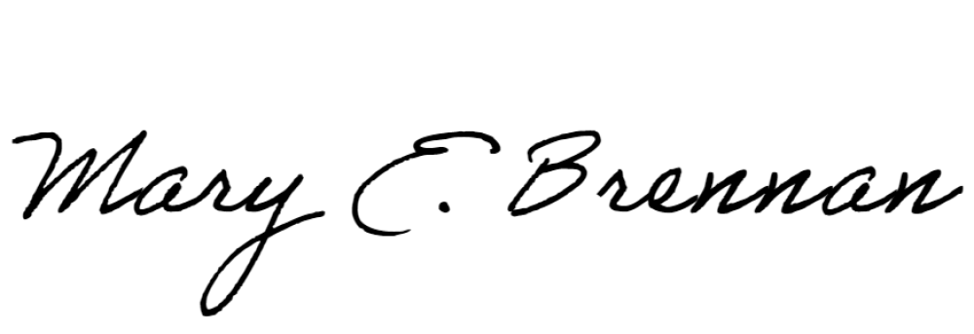Thank you for your consideration of this request.

Sincerely,

Mary E. Brennan Regulatory Affairs Officer

[BrennanM@michigan.gov](mailto:BrennanM@michigan.gov)

Copies to:

Timothy Reeves and Rachel Hughart, Legal Counsel, JCAR Katherine Wienczewski, Director, Michigan Office of Administrative Hearings

and Rules

Chardae Burton, Director, MDHHS Legislative Affairs Administrative Rules Division, [MOAHR-Rules@michigan.gov](mailto:MOAHR-Rules@michigan.gov)

Jeffrey Duncan, State Registrar and Director of Vital Records

and Health Statistics

2